FOR IMMEDIATE RELEASE

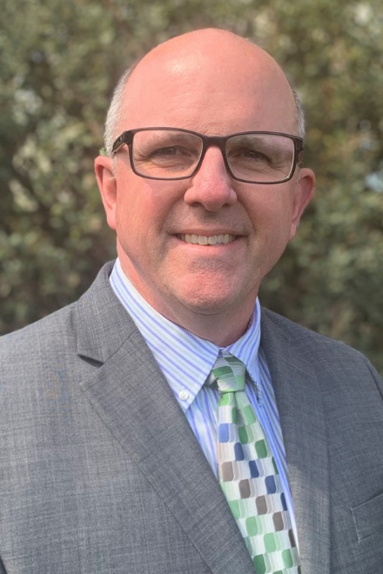
Brian K. Sanders, Ed.D. | Julius Sokenu, Ed.D.

VCCCD Names Two Finalists for Moorpark College President
Candidates will participate in forum with the District community

Camarillo, Calif. (April 2, 2021)—The Ventura County Community College District (VCCCD) board of trustees announces its two final candidates for the position of president at Moorpark College. The finalists are Brian K. Sanders, Ed.D., vice president of instruction at Columbia College in Sonora, Calif., and Julius Sokenu, Ed.D., interim president at Moorpark College.

“The president of Moorpark College is responsible for overseeing the academic and student services functions for the college, ensuring sound fiscal and facilities management, and implementing policies and procedures aligned with the District and college,” said Board Chair Joshua Chancer. “It’s a challenging position, and one that provides the utmost reward: changing students’ lives.”

“These two finalists possess the necessary experience, academic credentials and organizational leadership skills to meet the diverse needs of the college’s approximately 14,000 students, the faculty and classified employees,” said Chancellor Greg Gillespie.

Both candidates will participate in a closed forum at noon on April 5. They will each have 45 minutes to speak to the college community and answer questions involving leadership in higher education.

The forums will include a brief introduction of each candidate, followed by the question-and-answer session. Feedback forms will be provided to those who attend, and the completed forms will go to the VCCCD board of trustees and chancellor for review.

Final interviews will take place April 6.

The Finalists (in alphabetical order):

Sanders has worked at Columbia College since 2015. He previously served as dean of the Science, Mathematics, and Engineering Division at Modesto Junior College. Sanders earned a doctorate in educational leadership through a joint program of the University California, Davis, and Sonoma State University. Sanders has a master’s degree in mathematics from the University of Oregon and a bachelor’s degree in mathematical sciences from the University of California, Santa Barbara.

Sokenu has held the position of interim president at Moorpark College since April 2019; he previously served as the vice president of academic affairs. Sokenu earned a doctorate in education, with an emphasis in curriculum and teaching, from Boston University and a master of fine arts degree, with an emphasis in creative writing, from Arizona State University. He holds bachelor’s degrees in English creative writing and business administration from the University of Southern California.

About Ventura County Community College District

The Ventura County Community College District is a member of the 116-campus California Community College system and serves approximately 31,000 students annually. The District's three colleges--Moorpark, Oxnard and Ventura--offer programs in general education for degrees and certificates, transfer to four-year colleges and universities, career technical education, and provide opportunities to engage in co-curricular campus activities. For more information, please visit vcccd.edu.

Media Contact:
Patti Blair
Director, Public Affairs and Marketing
Ventura County Community College District
communications@vcccd.edu

