

FOR IMMEDIATE RELEASE
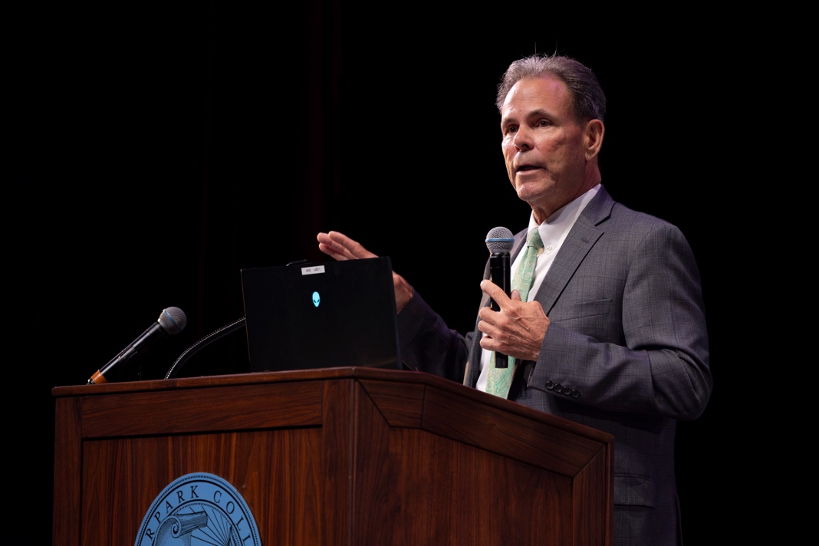
Community Colleges of Ventura County to Host State of the District Event
Event to highlight the growth, partnerships and momentum shaping Moorpark, Oxnard and Ventura colleges
CAMARILLO, Calif. (Sept. 30, 2026) —The Ventura County Community College District (VCCCD) is inviting the community to hear directly from its leadership at its State of the District event, bringing together elected officials, regional industry and nonprofit partners, educational leaders and friends of the district to celebrate the work of VCCCD’s students, faculty and employees, reflect on the District’s progress and look ahead to what's next. The free, public event takes place Monday, Oct. 19, 2026, at 3:30 p.m. at the Camarillo Public Library.
Chancellor Rick MacLennan, joined by Moorpark College President Julius Sokenu, Oxnard College Interim President Steve Hall and Ventura College President Luca Lewis, will offer a firsthand look at how VCCCD is responding to a changing Ventura County and creating more ways for students to access education, build careers and find opportunity close to home.
Topics will include increasing affordable bachelor's degree programs and opportunities for high school students to earn college credit, developing workforce pathways in the Highway 126 corridor and Santa Clara Valley and strengthening regional partnerships with organizations such as Naval Base Ventura County and the 805 HIVE Autonomous Innovation Center.
“Our colleges must continue to evolve with the communities we serve,” said MacLennan. “We’re building on strong work already underway while looking ahead at how we can expand opportunity for our students and respond to the needs of our communities and regional economy. This State of the District is a chance to bring people together, share the progress happening across our three colleges and talk about where we’re headed next.”
Light refreshments will be provided. For more information about the State of the District event and to RSVP, visit bit.ly/ccvc-state-of-the-district
About the Ventura County Community College District
The Ventura County Community College District is a member of the 116-campus California Community College system and serves approximately 30,000 students annually. The District's three colleges — Moorpark, Oxnard and Ventura — offer programs in general education for degrees and certificates, transfer to four-year colleges and universities, career technical education and provide opportunities to engage in co-curricular campus activities. For more information, visit vcccd.edu.
Media Contact:
Chelsee Russell
Executive Director of Operations
Ventura County Community College District
cbenterussell@vcccd.edu

