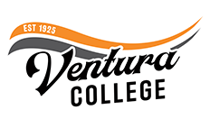

FOR IMMEDIATE RELEASE

VCCCD Announces Ventura College Presidential Finalists
General Public invited to attend Open Forums to provide feedback on candidates
Ventura, Calif. (March 25, 2026) — Ventura County Community College District (VCCCD) Chancellor Rick MacLennan is pleased to announce that there are three (3) finalists moving forward in the search process for the next President of Ventura College.
Listed below are candidate biographies and campus forums information. College faculty, staff, administration, and community members are invited to attend.
Ventura College President Finalist Forums
Ventura College Performing Arts Center (PAC)
4667 Telegraph Rd, Ventura, California

Monday, April 6, 2026
Dr. Jason Abreu: 10:00 a.m. – 11:00 a.m. and 2:00 p.m. – 3:00 p.m.

Tuesday, April 7, 2026
Dr. Luca Lewis: 10:00 a.m. – 11:00 a.m. and 2:00 p.m. – 3:00 p.m.

Wednesday, April 8, 2026
Dr. Feleccia Moore-Davis: 10:00 a.m. – 11:00 a.m. and 2:00 p.m. – 3:00 p.m.
Public forums will take place the week of April 6, and each candidate will participate in two
1-hour forums. We invite and encourage everyone to participate in the open forums. Forums will be made accessible to all faculty, administrators, staff, students, and the general public. There will be a brief introduction of each candidate, followed by a question-and-answer session. Forums will be conducted in-person in the Ventura College Performing Arts Center (PAC). All who attend will be asked to complete a feedback form.
We are looking forward to a successful completion of the presidential search process. If you have any questions or suggestions, please feel free to reach out to our ACCT Search Consultant, Julie Golder, ACCT Vice President of Search Services, at jgolder@acct.org or (202) 384-5816.

The Ventura College presidential finalists are (in alphabetical order):

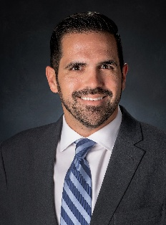
Jason Abreu, Ed.D., is the Vice President of Student Affairs for Tarrant County College, Trinity River Campus, TX. Previously, Dr. Abreu served as the Associate Vice President for Enrollment and University Registrar for Furman University, SC. Dr. Abreu earned a Doctor of Education degree in Organizational Leadership from Nova Southeastern University; a Master of Science degree in Leadership from Nova Southeastern University; and a Bachelor of Arts degree in Interdisciplinary Studies from Florida International University.

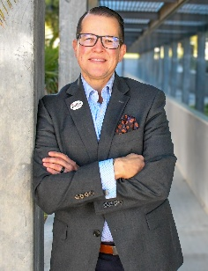
Luca Lewis, Ph.D., is the Interim President of Ventura College, CA. Previously, Dr. Lewis served as the Vice President of Student Affairs of Ventura College, CA. Dr. Lewis earned a Doctor of Philosophy degree in Higher Education Administration from the University of Idaho; a Master of Science degree in Interdisciplinary Studies from the University of Idaho; and a Bachelor of General Studies degree from the University of Idaho.

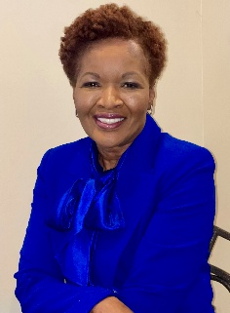
Feleccia Moore-Davis, Ph.D., is the Meramec Campus President of St. Louis Community College, MO. Previously, Dr. Moore-Davis served as the Provost of Tallahassee State College, FL. Dr. Moore-Davis earned a Doctor of Philosophy degree in Organizational Leadership from Regent University; a Master of Science degree in Industrial/Organizational Psychology from Texas A& M University; and a Bachelor of Science degree in Psychology from Xavier University of Louisiana.

About Ventura College
Ventura College, the first institution of higher education in Ventura County, has provided quality education to the community since 1925. A designated Hispanic-Serving Institution, the college enrolls over 13,000 students each semester at two campuses. VC offers over 70 disciplines of study in STEM fields, business, the arts, education, social/behavioral sciences, liberal arts, and health sciences. Named one of the nation’s top 150 community colleges by the Aspen Institute College Excellence Program, it is the largest provider of workforce participants in the county in manufacturing, automotive technology, and nursing. To learn more, visit VenturaCollege.edu.

About Ventura County Community College District
The Ventura County Community College District is a member of the 116-campus California Community College system and serves approximately 30,000 students annually. The District's three colleges—Moorpark, Oxnard and Ventura—offer programs in general education for degrees and certificates, transfer to four-year colleges and universities, career technical education and provide opportunities to engage in co-curricular campus activities. For more information, visit vcccd.edu.

