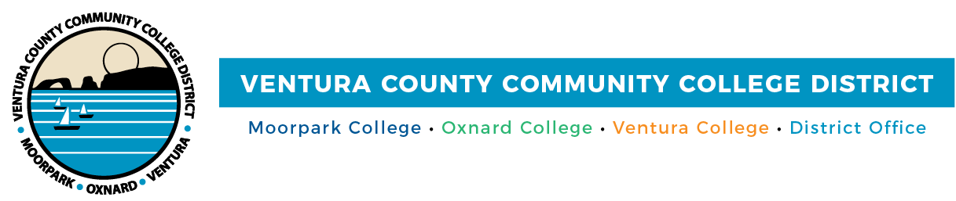
FOR IMMEDIATE RELEASE
Ventura County Community College District Vice Chancellor Named Educational Leader of the Year by Ventura County Leadership Academy
Dr. Cynthia Herrera recognized for expanding educational opportunity and
community partnerships
Camarillo, Calif. (May 1, 2026) — With work rooted in equity, collaboration and a deep belief that education is a driver of community strength and opportunity, Dr. Cynthia Herrera, Vice Chancellor of Institutional Effectiveness for Ventura County Community College District (VCCCD), has received recognition as the Ventura County Leadership Academy’s (VCLA) Educational Leader of the Year. Dr. Herrera will be honored for her authentic leadership and dedication to expanding opportunity for students.
The annual VCLA Journey to Leadership Awards recognize outstanding leaders who exemplify the organization’s mission of connecting people and issues to strengthen Ventura County. The Educational Leader of the Year honor is for those who guide and prepare others through leadership that demonstrates equity, diversity and academic excellence. It was these qualities that led VCCCD Chancellor Rick MacLennan to nominate Dr. Herrera for the award.
“Dr. Herrera’s leadership has strengthened our educational ecosystem and expanded opportunity for students and families throughout Ventura County,” said Chancellor Rick MacLennan. “Her work connecting education, workforce development and community partnerships reflects the very best of what our district stands for.”
Dr. Herrera built her career from the ground up, dedicating more than 15 years to the VCCCD from Dean of Institutional Effectiveness at Oxnard College to roles that expanded her reach across every level of the district. A founding member of the Ventura County STEM (Science, Technology, Engineering & Math) Regional Network, she has championed educational pathways spanning the full P-20 pipeline, from preschool through graduate education. She has also authored more than $40 million in state and federal grants to strengthen programs that serve underrepresented students and emerging industries.
As an active board member of Goodwill Industries of Ventura and Santa Barbara Counties, the Boys & Girls Clubs of Greater Oxnard and Port Hueneme and the Museum of Ventura County, her influence extends well beyond the classroom and the boardroom. Dr. Herrera also serves as Chair of the Economic Development Collaborative, which is reflective of her belief that education and community are inseparable. As a published author and presenter in higher education, she brings to every role the same qualities that define her leadership: a genuine investment in people and a commitment to equity that shows up in the work, not just the words.
Her leadership has earned recognition across multiple sectors. Her prior honors include the Ventura County Woman of the Year award, two consecutive Chairman’s Awards of Excellence from the Oxnard Chamber of Commerce, the Pacific Coast Business Times Latino Business Award and the Ventura County Star “25 over 50” award, and the California State University Channel Islands (CSUCI) honorary doctorate of Humane Letters.
"Receiving this recognition from the Ventura County Leadership Academy is deeply meaningful because it reflects the collective work of so many dedicated educators, partners and community leaders across Ventura County," said Dr. Herrera. "I have always believed that education is the foundation of economic mobility and community vitality, and this honor reinforces our shared responsibility to create systems that expand access and opportunity for every student. This recognition is not just about individual leadership, it represents the power of collaboration and our continued commitment to building pathways that connect education, workforce and community in transformative ways."
Dr. Herrera is one of many dedicated educators and administrators across the VCCCD working every day to expand access, strengthen communities and help students reach their goals. To learn more about the community colleges of Ventura County and the work they do to support student opportunity, visit vcccd.edu.

About Ventura County Community College District
The Ventura County Community College District is a member of the 116-campus California Community College system and serves approximately 30,000 students annually. The District’s three colleges—Moorpark, Oxnard and Ventura—offer programs in general education for degrees and certificates, transfer to four-year colleges and universities, career technical education and provide opportunities to engage in co-curricular campus activities. For more information, visit vcccd.edu.

Media Contact:
Outreach and Marketing
Ventura County Community College District
communications@vcccd.edu

