

FOR IMMEDIATE RELEASE
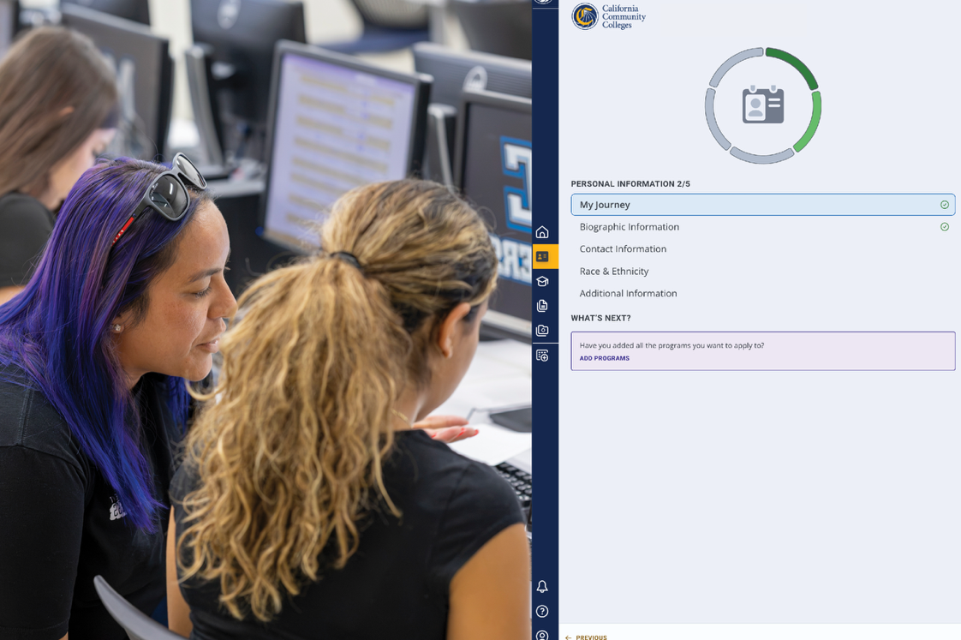
VCCCD Opens a Clearer Path to College with New Student Enrollment Experience
New CCCStart platform launches Oct. 8, ahead of the statewide transition
CAMARILLO, Calif. (Sept. 29, 2026) — Students can soon get started at Moorpark, Oxnard and Ventura colleges in about 15 minutes, as the Ventura County Community College District (VCCCD) launches its new, simplified enrollment experience through CCCStart on October 8.
The district is among the first in California to adopt CCCStart, an enrollment platform that will replace the long-standing CCCApply system statewide by June 2027. This change is part of a statewide effort led by the California Community Colleges Chancellor’s Office to modernize how students begin college. The new platform was designed to expand access, improve the student experience and protect against fraud.
“Community colleges are built around access, and that should be reflected from a student’s very first interaction with us,” said Rick MacLennan, chancellor of VCCCD. “CCCStart makes that first step simpler and creates a clearer, more welcoming path into college, whether a student is coming to us directly from high school, returning after years away or pursuing new skills for their career.”
Instead of presenting every prospective student with the same standard form, CCCStart asks students about their goals up front and shows only the questions relevant to them. A high school student exploring dual enrollment, an adult returning to finish a degree and a worker seeking noncredit career training will each see an experience built around their unique student journey.
Meaningfully, CCCStart also shifts the tone of a student’s introduction to the colleges — from applying, which suggests a student has to measure up, to enrollment, reflecting what community colleges have always been: open to anyone ready to learn.
"Access isn't just about opening doors — it's about making sure every student who walks through them knows they belong," said Joel Diaz, registrar for Oxnard College. "When we remove barriers for first-generation and returning students, our entire community grows stronger."
CCCStart also strengthens protections against fraudulent enrollment, an issue community colleges across California have been working to address. By confirming that each person getting started is a real student, the platform helps ensure class seats and financial aid go to the people they're meant for. Students can verify their identity online with ID.me and the DMV Mobile Wallet or in person at the college.
Prospective students can continue to get started through CCCApply until CCCStart launches Oct. 8. For more information about the Community Colleges of Ventura County, visit vcccd.edu.
About Ventura County Community College District
The Ventura County Community College District is a member of the 116-campus California Community College system and serves approximately 30,000 students annually. The District’s three colleges — Moorpark, Oxnard and Ventura — offer programs in general education for degrees and certificates, transfer to four-year colleges and universities, career technical education and provide opportunities to engage in co-curricular campus activities. For more information, visit vcccd.edu.
Media Contact:
Outreach and Marketing
Ventura County Community College District
communications@vcccd.edu

