FOR IMMEDIATE RELEASE
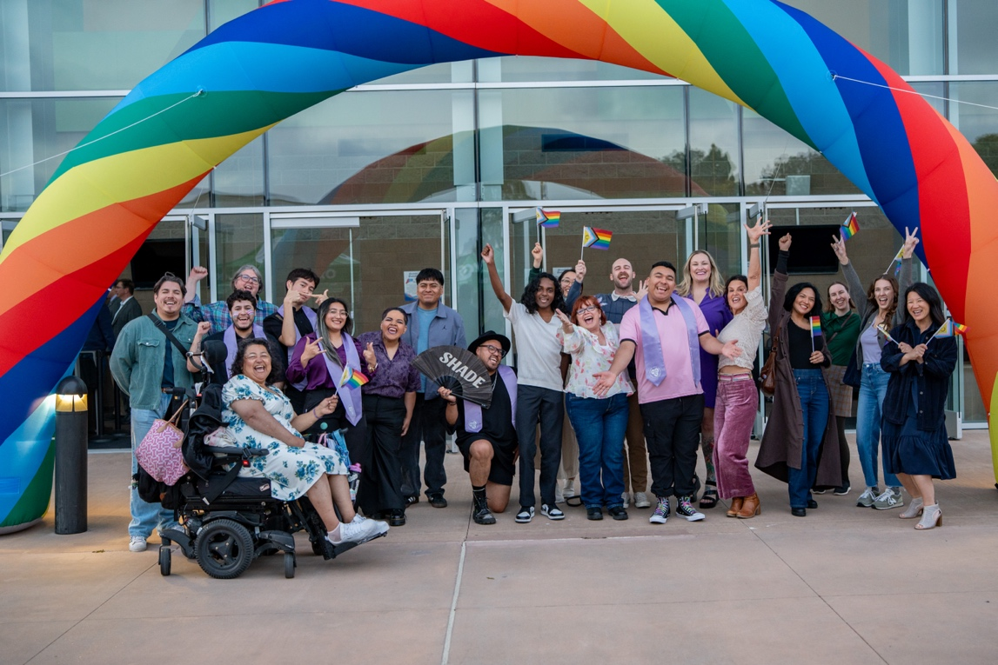
Celebrants gather under the rainbow arch at Oxnard College's Lavender Graduation 2026 on May 1.
Ventura County Community College District Honors LGBTQIA+ Graduates as Lavender Graduation Returns to Its Roots
Returning to Oxnard College, where the tradition began, the districtwide celebration honors identity, resilience, and belonging
CAMARILLO, Calif. (May 13, 2026) — Three years ago, Oxnard College hosted the first Lavender Graduation in the history of the Community Colleges of Ventura County. On May 1, 2026, the celebration returned to the Performing Arts Building with its corridor of employee allies and a giant inflatable rainbow that welcomed attendees home.
Lavender Graduation has become a beloved districtwide tradition, rotating annually among Moorpark, Oxnard and Ventura colleges since its creation in the 2022-23 academic year. Designed to celebrate the achievements and identities of LGBTQIA+ students across the district, this year’s return to Oxnard College marked a full-circle moment for a program that has grown each year since its founding.
For the first time in the event’s history, this year’s ceremony was led by three Lavender Graduation alumni serving as masters of ceremony: Lux Orozco, Nathan Cerritos and Cris Perez. For Orozco, the moment carried particular significance. They had attended the very first Lavender Graduation at Oxnard College in 2023 as a student, and returned this year as a Cal State Northridge transfer and emcee.
“To me, Lavender Graduation is a wonderful celebration where we get to be ourselves with the friends we made while in community college, and the faculty and staff who showed us support along the way,” said Orozco. “To incoming students like me, I would tell them to find their community, because the community I found at Oxnard College is still part of my life today and that is something beautiful that I hope other students can also find.”
Remarks from district and college leadership carried the same spirit of community and belonging, with Chancellor Rick MacLennan grounding the celebration in the district’s core values and each speaker drawing on personal experience to affirm the district’s commitment to all students.
“To our LGBTQIA+ graduates from all three of our colleges, you have made our district community richer through your presence, your perspectives, and your courage,” said Chancellor Rick MacLennan. “Each of you has contributed uniquely to our colleges and strengthened our community in meaningful ways.”
Student speakers from each of the three colleges shared their journeys and honored the allies who supported them along the way. Graduates then crossed the stage with their affirmed names and in the clothes that made them feel most fully themselves — for some, the only stage they will ever cross in complete affirmation of who they are.
The evening was made possible by a districtwide committee driven by passion, not position, chaired by Oxnard College’s Gilbert Downs and supported by staff, faculty and volunteers across the district — including VCCCD Lt. Cesar Romero, who donated his DJ services for the after party.
Oxnard College student and committee member Diego Ibarra, who will graduate in spring 2026, captured what the evening meant for so many in the room:
“The Lavender Graduation was deeply meaningful because it honored LGBTQIA+ students under the rainbow umbrella and created a space for celebration, recognition, and community. It’s essential that VCCCD continues showing up for LGBTQIA+ students to advance a vision of equity, inclusion, and belonging.”
For more information about Lavender Graduation and the ways the Community Colleges of Ventura County support LGBTQIA+ students, visit vcccd.edu/students/lgbtq.
About Ventura County Community College District
The Ventura County Community College District (VCCCD) is a member of the 116-campus California Community College system and serves approximately 30,000 students annually. The District’s three colleges — Moorpark, Oxnard and Ventura — offer programs in general education for degrees and certificates, transfer to four-year colleges and universities, career technical education and provide opportunities to engage in co-curricular campus activities. For more information, visit vcccd.edu.
Media Contact:
Outreach and Marketing
Ventura County Community College District
communications@vcccd.edu

