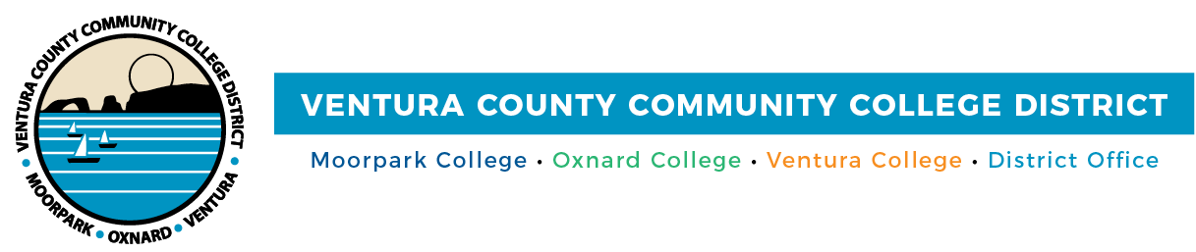

FOR IMMEDIATE RELEASE

Campus Bookstores at the Ventura County Community College District Now Accepting CalFresh Benefits

CAMARILLO, Calif., April 30, 2026 — Making it easier than ever for students to put food on the table, campus bookstores at the community colleges of Ventura County now accept Supplemental Nutrition Assistance Program (SNAP) benefits, known in California as CalFresh. The expanded payment option launched March 30, 2026.

According to the 2025 Real College California Basic Needs Survey, 46% of community college students statewide reported food insecurity — and research shows that more than half of eligible students aren't accessing the CalFresh benefits available to them. By upgrading campus bookstore systems to accept Electronic Benefits Transfer (EBT) cards, VCCCD is making it easier for students who are already enrolled in CalFresh to use their benefits right on campus.

“When students have reliable access to basic needs like food, they are better positioned to stay enrolled, stay focused, and reach their goals,” said VCCCD Chancellor Rick MacLennan. “Accepting CalFresh benefits at our campus bookstores is an important step forward and another way we are reducing barriers for students — helping ensure they have one more resource to support their success.”

Follett Higher Education Group, which operates the bookstores at all three campuses, upgraded its point-of-sale systems to enable EBT transactions as part of a broader commitment to expanding food access for students across the district.

“Our goal is to reduce barriers and better serve our campus communities,” said Anna Wells, market leader for Follett Higher Education Group. “Accepting SNAP benefits is an important step in ensuring access to essential food items for those who need them.”

Students seeking information about CalFresh eligibility, enrollment, or other basic needs resources are encouraged to visit their campus Basic Needs Center or explore the full directory of student services available at each college at vcccd.edu/students/student-services-directory.

About the Ventura County Community College District
The Ventura County Community College District is a member of the 116-campus California Community College system and serves approximately 30,000 students annually. The District’s three colleges — Moorpark, Oxnard and Ventura — offer programs in general education for degrees and certificates, transfer to four-year colleges and universities, career technical education and provide opportunities to engage in co-curricular campus activities. For more information, visit vcccd.edu.

Media Contact:
Outreach and Marketing
Ventura County Community College District
communications@vcccd.edu

