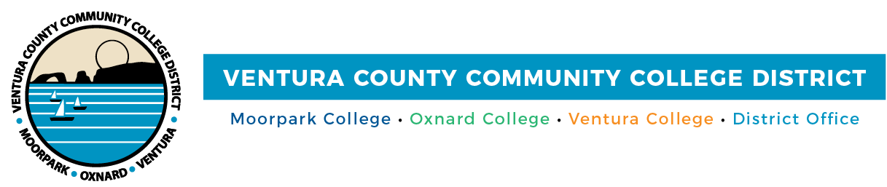
FOR IMMEDIATE RELEASE

Ventura County Community College District Announces Selection of Dr. Luca E. Lewis as Ventura College President

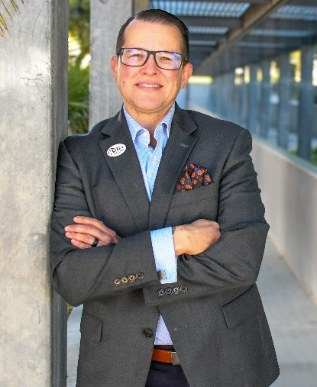

Dr. Luca E. Lewis, incoming President of Ventura College.

Camarillo, Calif. (April 17, 2026) — The Ventura County Community College District (VCCCD) is announcing the selection of Dr. Luca E. Lewis as the next President of Ventura College, pending approval by the Board of Trustees at its May 12 meeting.

“Students are at the heart of every decision we make as a Board. Dr. Lewis has consistently demonstrated strong leadership, a clear dedication to student success and social justice, and a commitment to ensuring Ventura College remains aligned with the needs of its community. We look forward to building on that momentum in the years ahead,” said Board Chair Gabriela Torres.

Dr. Lewis has served as Interim President since September 2025, providing steady, thoughtful leadership during a period of institutional transition. During this time, Ventura College has strengthened its focus on student success, equity, and community engagement, and continues to be recognized among the nation’s top-performing community colleges as an Aspen Prize Top 200–eligible institution.

Dr. Lewis brings more than 20 years of progressive leadership experience in higher education, with a demonstrated record of advancing access, enrollment growth and student achievement across diverse college environments. Prior to his interim presidency, he served as Vice President of Student Affairs at Ventura College, where he led strategic enrollment and retention initiatives, expanded student engagement programs, and strengthened support systems that improved student persistence and success.

Previously, Dr. Lewis served as Associate Vice Chancellor of Education and Student Services at the West Hills Community College District, where he provided executive leadership for academic and student services across a multi-college system. In that role, he oversaw significant grant-funded initiatives, advanced workforce and academic pathway development, and implemented strategies that supported enrollment and completion.

Earlier in his career, Dr. Lewis served as Vice President for Student Services at Whatcom Community College in Washington, where he led a comprehensive student services division and supported key initiatives including the development of a one-stop student success center, expansion of dual enrollment partnerships, and implementation of equity-focused practices to support improved student outcomes. He also held leadership roles at Edmonds Community College, Bellevue College and the University of Washington, Tacoma.

“This is an important moment for Ventura College, and Dr. Lewis brings the experience and approach needed to lead with focus and purpose. He understands the campus, is deeply committed to students, and has shown the ability to move the college forward through meaningful engagement with faculty and staff. I’m confident in the direction ahead under his leadership,” said Chancellor Rick MacLennan.

In addition to his administrative leadership, Dr. Lewis has taught as an adjunct faculty member at multiple institutions and is an active contributor to the field through publications, presentations, and leadership development focused on equity, inclusion and institutional transformation.

Dr. Lewis holds a Ph.D. in Higher Education Administration, as well as master’s and bachelor’s degrees, from the University of Idaho.

Dr. Lewis will continue to build on Ventura College’s strong foundation, advancing student-centered innovation, strengthening community partnerships, and expanding opportunities that support student success, workforce development and regional impact.

About Ventura County Community College District

The Ventura County Community College District is a member of the 116-campus California Community College system and serves approximately 30,000 students annually. The District’s three colleges—Moorpark, Oxnard and Ventura—offer programs in general education for degrees and certificates, transfer to four-year colleges and universities, career technical education and provide opportunities to engage in co-curricular campus activities. For more information, visit vcccd.edu.

Media Contact:
Outreach and Marketing
Ventura County Community College District
communications@vcccd.edu

