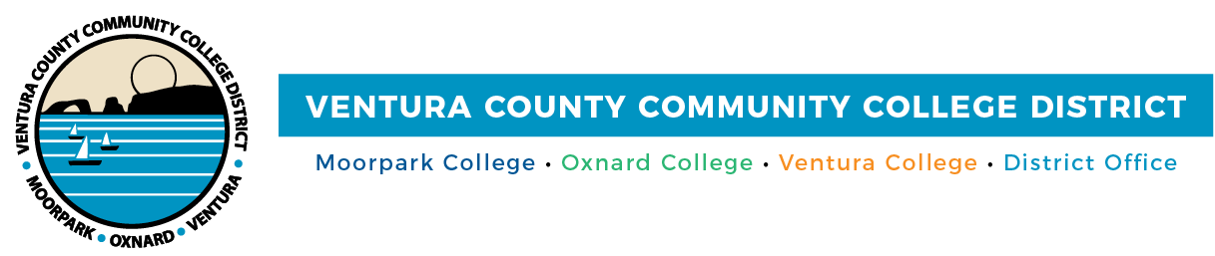

FOR IMMEDIATE RELEASE

Ventura County Community College District Joins National Entrepreneurship Pilot to Expand Access to Business Financing Education

VCCCD hosts free workshop connecting local entrepreneurs with lenders and business development experts

Camarillo, Calif. (April 17, 2026) — The Ventura County Community College District (VCCCD) is hosting “Foundations of Financing for Entrepreneurs,” a free workshop today at the HIVE Autonomous Innovation Center in Camarillo.

The workshop is part of a national pilot program, CEED to Success, designed to expand entrepreneurship and business financing education to underserved founders. As part of this initiative, VCCCD is partnering with the program’s founder, Baker Hill, through its Center for Entrepreneurship and Economic Development (CEED) and a partnership with the National Association for Community College Entrepreneurship (NACCE).

The workshop brings together entrepreneurs, lenders and economic development experts to help attendees navigate the funding landscape. Programming includes an overview of resources for Ventura County entrepreneurs, a financing fundamentals presentation, a loan process walkthrough led by Montecito Bank & Trust, and an entrepreneur spotlight. Space is limited to 30 participants.

“At the Ventura County Community College District, we are committed to ensuring that every aspiring entrepreneur, especially those from historically underserved communities, has access to the knowledge, resources, and strategic partnerships needed to secure capital and successfully grow their business,” said Dr. Cynthia Herrera, Vice Chancellor of Institutional Effectiveness.

The workshop takes place today, April 17, 2026, from 3 to 6 p.m. at the HIVE Autonomous Innovation Center, 555 Airport Way, STE A, Camarillo, Calif. To register or for more information, visit https://www.eventbrite.com/e/nacce-community-entrepreneurial-ecosystem-development-ceed-workshop-tickets-1986089711792.

About the Ventura County Community College District

The Ventura County Community College District is a member of the 116-campus California Community College system and serves approximately 30,000 students annually. The District’s three colleges — Moorpark, Oxnard and Ventura — offer programs in general education for degrees and certificates, transfer to four-year colleges and universities, career technical education and provide opportunities to engage in co-curricular campus activities. For more information, visit vcccd.edu.

About Baker Hill

Baker Hill is the leading provider of lending technology for banks and credit unions across the United States. Each month, financial institutions use Baker Hill’s platform to process more than $7 billion in lending originations—helping them Lend Better, Lend Faster, and Lend More™ in their communities. Backed by Flexpoint Ford, a private equity firm, Baker Hill delivers the scale, security, and innovation required to meet the demands of modern banking. The company is headquartered in Carmel, Indiana, with operations in Santa Barbara, California.

For more information, visit www.bakerhill.com.

About NACCE

NACCE is an organization of educators, administrators, presidents, and entrepreneurs focused on igniting entrepreneurship in their communities and colleges. Its mission is to provide leadership and sustainable, scalable resources to foster entrepreneurial thinking and action in one of the largest entrepreneurial ecosystems in North America. NACCE represents a dynamic community of technical and community colleges, serving more than 3.3 million students.

For more information, visit www.nacce.com.

Media Contact:
Outreach and Marketing
Ventura County Community College District
communications@vcccd.edu

Baker Hill
Penny Spehar, Spokesperson
(317) 814-1260

