**FOR IMMEDIATE RELEASE**

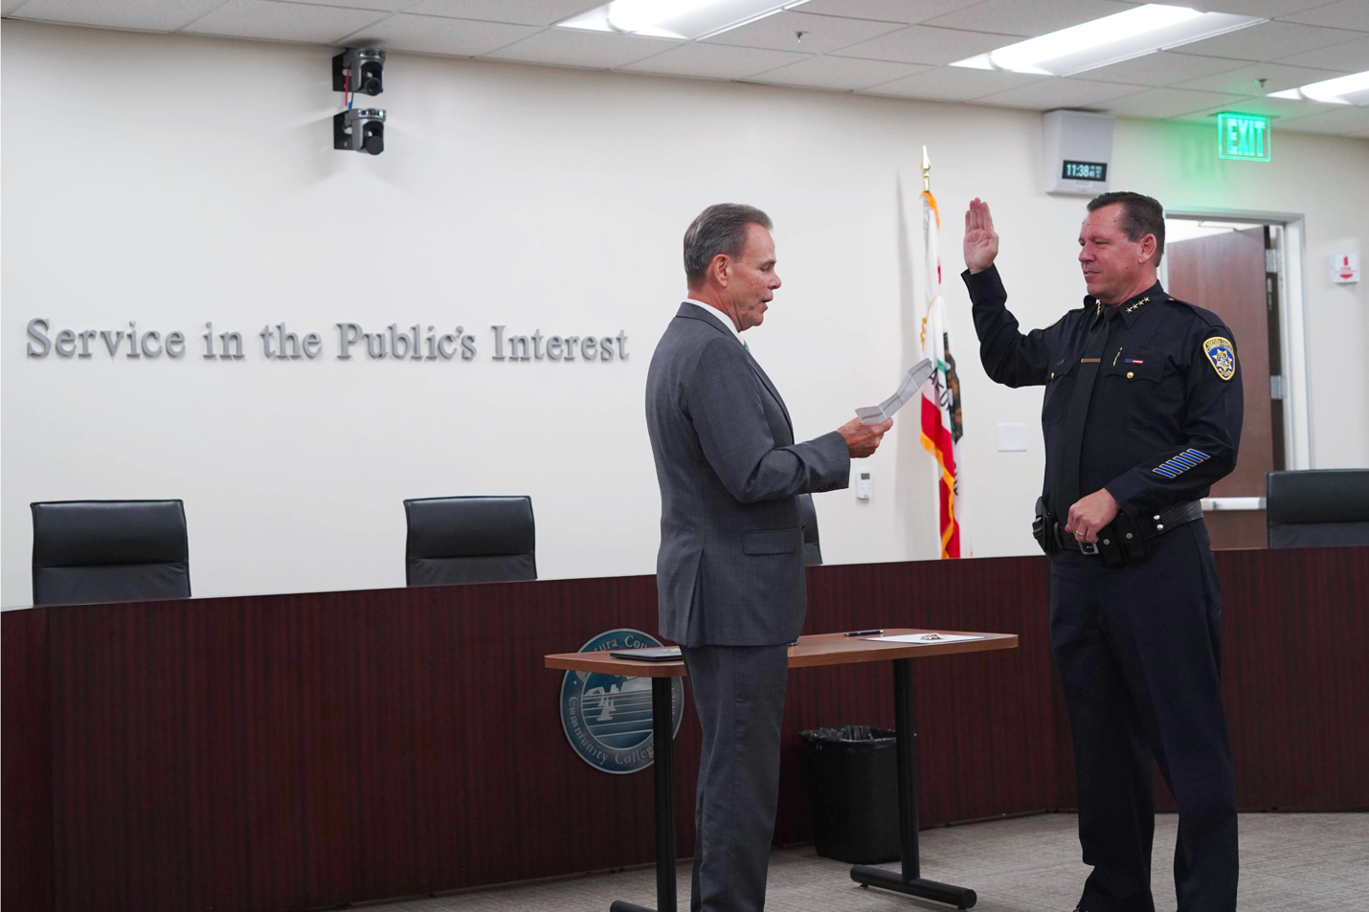

**VCCCD Swears In Robert Davidson as New Chief of Police***Ventura County resident and former assistant sheriff brings 30+ years of law enforcement experience*

**Camarillo, Calif.** (Sept. 23, 2025) — The Ventura County Community College District (VCCCD) swore in Robert Davidson as its new chief of police September 22, bringing nearly 35 years of county law enforcement experience to guide and strengthen the District’s police department.

Davidson began his career with the Ventura County Sheriff’s Office in 1991 where he rose up through the ranks to Assistant Sheriff. Over more than three decades, he successfully led major investigations, directed Internal Affairs and training programs, and oversaw the Sheriff’s largest division with a $120 million budget.

“Chief Davidson’s decades of leadership and service to Ventura County will be an asset to our students, employees, and community,” said Rick MacLennan, chancellor of the VCCCD. “His proven experience and commitment to public service will further enhance the welcoming, supportive environment our colleges provide for learning and growth.”

Davidson earned a Master’s Degree in Leadership with a concentration in Public Policy from the University of Southern California, and a Bachelor of Arts in Political Science from California State University, Stanislaus. He is also a graduate of the POST Command College and holds a POST Management Certificate.

“Chief Davidson’s extensive background and thoughtful leadership will be a tremendous resource for our District,” said Valerie Mitchell, vice chancellor of Business and Administrative Services for the VCCCD. “His collaborative approach and deep roots in the community will strengthen our police department’s role as a trusted partner in supporting student success and maintaining the welcoming environment our colleges are known for.”

Davidson succeeds interim Police Chief Michael Pallotto, who provided steady leadership during the transition following the service of former Police Chief Kelli Florman. For more information about the Ventura County Community College District Police Department and Chief Davidson, visit [vcccd.edu/police](https://www.vcccd.edu/police).

**About Ventura County Community College District**

*The Ventura County Community College District is a member of the 116-campus California Community College system and serves approximately 30,000 students annually. The District's three colleges—Moorpark, Oxnard and Ventura—offer programs in general education for degrees and certificates, transfer to four-year colleges and universities, career technical education and provide opportunities to engage in co-curricular campus activities. For more information, visit* [*vcccd.edu*](http://www.vcccd.edu)*.*

**Media Contact:**

Outreach and Marketing

Ventura County Community College District

[communications@vcccd.edu](mailto:communications@vcccd.edu)