**FOR IMMEDIATE RELEASE**

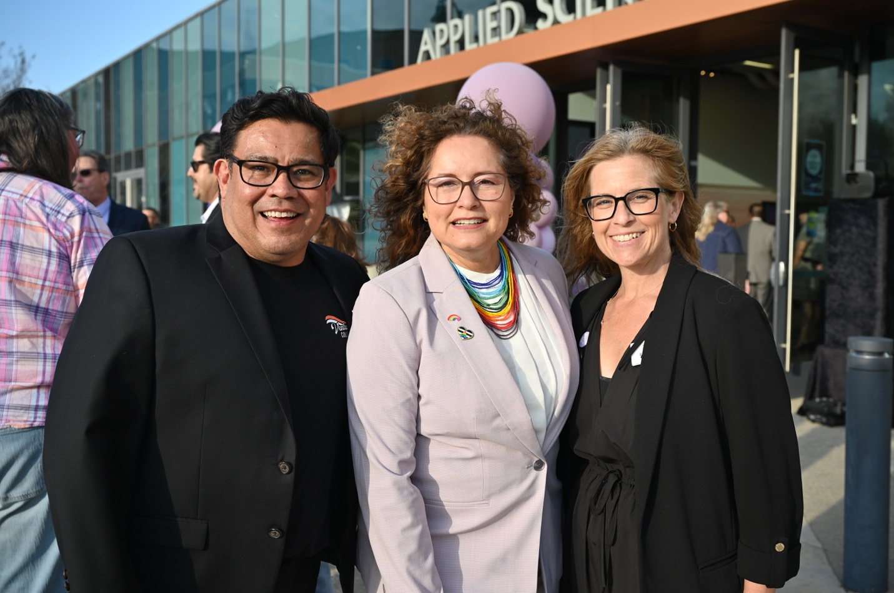

**Community Colleges of Ventura County Uplift LGBTQIA+ Graduates at Third Annual Lavender Celebration**

*Hosted by Ventura College, the districtwide tradition honors identity, joy, and belonging*

**Camarillo, Calif.** (May 2, 2025) — The Applied Science Center at Ventura College was filled with the light of hope and deep communal joy as graduates, their loved ones, and District employees danced to the rhythm of the DJ’s music at this year’s Lavender Graduation celebration. Hosted by Ventura College on Friday, April 25, this annual Districtwide event celebrates LGBTQIA+ graduates and the vibrant community that surrounds them.

Now in its third year, Lavender Graduation has become a beloved tradition that fills students and employees alike with anticipation. The ceremony and afterparty reception, hosted in a rotation among the three colleges, was initially created in the 2022-23 academic year to be an inclusive graduation celebration that honors the achievements and identities of LGBTQIA+ students across the district. Since its inaugural year, the event has continued to draw a guest list of graduates, continuing students, and their supporters, as well as the LGBTQIA+ community members and allies employed by the district as faculty, classified professionals, and administrators.

“As President of Ventura College, it was a privilege to host this year’s Lavender Graduation,” said Claudia Lourido-Habib. “This event speaks to the spirit of our campus—welcoming, joyful, and deeply committed to every student’s success. I was especially proud of our staff and faculty who helped create a space where our LGBTQIA+ graduates felt uplifted, celebrated, safe to shine, and had fun! It was a beautiful reflection of who we are and who we’re continually striving to be.”

This year’s program featured student speeches, remarks from all three college presidents and the chancellor, and reflections on the significance and history of Lavender Graduation—including the challenges LGBTQIA+ students continue to face today. In a time of uncertainty where LGBTQIA+ visibility is under threat from various political and social entities, these messages emphasized the importance of telling our students and community members, out or not, that they are not alone—that they belong, are valued, and have a community ready to stand beside them. These values were further highlighted during the awards ceremony, where individuals nominated by students were awarded for the ways they’ve made their campuses safer, more welcoming, and more just.

Each year, the program concludes with the presentation of lavender stoles embroidered with a districtwide VCCCD logo. Each participating student has the opportunity to walk across the stage with their affirmed name, the clothes that make them feel the most comfortable, and receive a stole from their club advisors—a moment of recognition that, for some students, may be the only time they walk a stage in full affirmation of who they are.

“Lavender Graduation is a meaningful expression of our district’s core values—equity, inclusion, and student belonging,” said Chancellor Rick MacLennan. “It’s one of many celebrations that honor each student’s unique journey, affirming our commitment to creating hope and opportunity, one student at a time. These moments remind us that education is not only about achievement, but about building community, uplifting identity, and ensuring every student feels truly seen and supported.”

Planned by a districtwide committee driven by passion, not position, it reminds us that love and support make success possible—even when the odds feel stacked against it. At the Community Colleges of Ventura County, LGBTQIA+ students are celebrated for who they are, as they are—no conditions, no exceptions.

For more information about Lavender Graduation and the ways the Community Colleges of Ventura County support LGBTQIA+ students, [visit the VCCCD LGBTQIA+ webpage](https://www.vcccd.edu/students/lgbtq).

**About Ventura County Community College District**

*The Ventura County Community College District is a member of the 116-campus California Community College system and serves approximately 30,000 students annually. The District's three colleges—Moorpark, Oxnard and Ventura—offer programs in general education for degrees and certificates, transfer to four-year colleges and universities, career technical education and provide opportunities to engage in co-curricular campus activities. For more information, visit* [*vcccd.edu*](http://www.vcccd.edu)*.*

**Media Contact:**

Outreach and Marketing

Ventura County Community College District

[communications@vcccd.edu](mailto:communications@vcccd.edu)