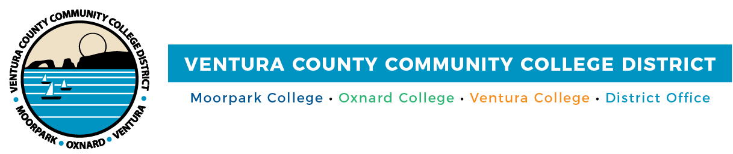

FOR IMMEDIATE RELEASE

Community Colleges of Ventura County Ranked Among Top 25 in State for Student ROI
The distinction reflects the three colleges’ work to support access to economic mobility

Camarillo, Calif. (Aug. 18, 2025) — All three Community Colleges of Ventura County—Moorpark, Oxnard and Ventura—ranked among the Top 25 in California for return on investment, according to a new College Futures Foundation report on economic mobility. The Golden Returns report, which measures how quickly students recoup educational costs through post-enrollment earnings, placed Moorpark at #7, Oxnard at #9 and Ventura at #19 statewide.
The analysis was conducted in partnership between the College Futures Foundation and the HEA group, a research and consulting agency focused on college access, value and economic mobility. The comparison covered 327 public, private nonprofit and for-profit community and career colleges across 12 California economic regions.
Using the Price-to-Earnings Premium metric, the research team calculated the time it takes for a typical student to recover out-of-pocket educational costs based on post-completion wage gains measured in terms of months to break even. Moorpark, Oxnard and Ventura colleges were all found to deliver ROI in less than one year, leading the entire Central Coast region.
“Our colleges are deeply embedded in the communities we serve, and this recognition underscores how powerfully that local connection translates into real economic outcomes for our students,” said Rick MacLennan, chancellor of the Ventura County Community College District. “Being the top-ranked colleges in the Central Coast region reflects our commitment to meeting regional workforce needs and expanding opportunity close to home.”
Designed to help students, families and policymakers understand which institutions offer real economic value, especially for learners from historically underserved communities, the report highlights the need for colleges to use their data to improve outcomes regionally and across the state.
“This recognition is about more than numbers—it’s about the lives behind them,” said Gabriela Torres, chair of the Ventura County Community College District Board of Trustees. “Our colleges are opening doors for students who have long been excluded from economic opportunity. Seeing our students succeed, thrive and begin to build generational change—that’s the return we care most about.”
This recognition reflects the colleges’ longstanding commitment to affordable education, local workforce partnerships and a mission centered on expanding opportunity for Ventura County learners. To learn more about the Community Colleges of Ventura County and the work they do to support access to economic mobility, visit vcccd.edu.
About Ventura County Community College District
The Ventura County Community College District is a member of the 116-campus California Community College system and serves approximately 30,000 students annually. The District's three colleges—Moorpark, Oxnard and Ventura—offer programs in general education for degrees and certificates, transfer to four-year colleges and universities, career technical education and provide opportunities to engage in co-curricular campus activities. For more information, visit vcccd.edu.

Media Contact:
Outreach and Marketing
Ventura County Community College District
communications@vcccd.edu

