**FOR IMMEDIATE RELEASE**

**[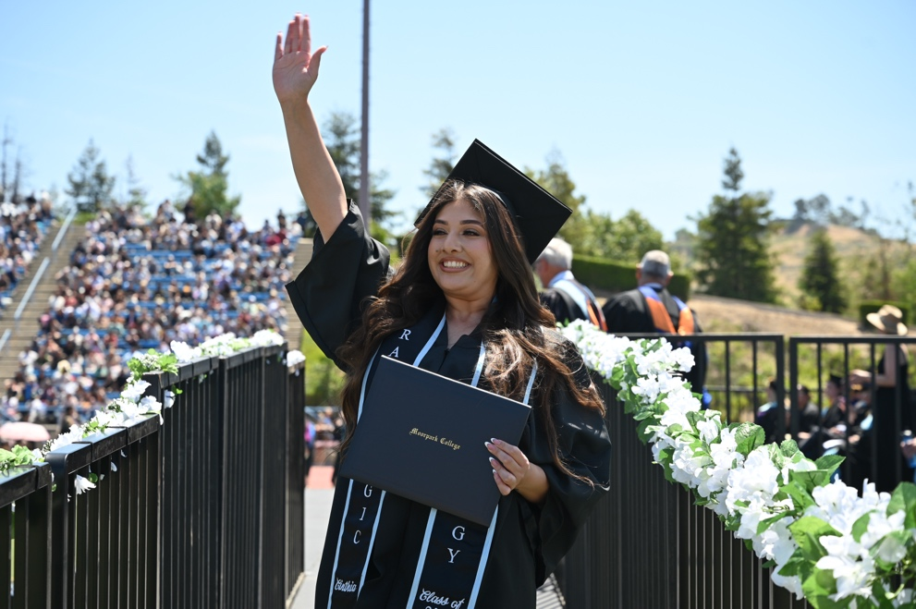](https://vcccd.mediavalet.com/portals/VCCCD-Commencements)**

**Community Colleges of Ventura County Honor over 6,000 Graduates at 2025 Commencement**

*New college presidents and board chair participate in first commencements in their new roles*

**Camarillo, Calif.** (May 28, 2025) — This week, the Community Colleges of Ventura County celebrated the successes of 6,277 students during the 2025 Commencement ceremonies. The ceremonies were held at Moorpark and Oxnard colleges on May 22 and Ventura College on May 23.

The Class of 2025 earned a collective 5,316 certificates and 8,108 degrees. These tangible awards are symbolic of thousands of hours of class-time, practical lab work, and hands-on learning on the job with internships and apprenticeships. Ventura County’s graduates are tomorrow’s nurses, sheriffs, fire fighters, veterinarians, child care providers, and dentists. They will be scholars and researchers looking into the major issues of our age and they will be the technical workers implementing our sustainable, green future.

“Graduation marks a turning point — not just for our students, but for the communities they will impact,” said Rick MacLennan, chancellor of the Ventura County Community College District. “These graduates have worked hard, overcome challenges and gained the skills to thrive in a changing world. They’re ready to contribute, to lead and to build a better future for all of us.”

“Every student who walks across the stage today carries not just their own dreams, but the hopes of families and communities who believe in them,” said Gabriela Torres, chair of the VCCCD Board of Trustees. “This moment is a testament to what’s possible when we invest in equity, access and the full potential of every learner.”

With their graduates now ready to take the next step, the college presidents spoke to the power of this moment—and what comes next:

“Commencement is a celebration of resilience, growth, and hope,” said Julius Sokenu, president of Moorpark College. “Our graduates have cultivated their strengths, deepened their purpose, and contributed to a legacy of learning that uplifts families and transforms communities. As they step forward, they carry not only the knowledge gained in classrooms, practicum, and athletic competitions but also the spirit of service and excellence that defines Moorpark College.”

"We are proud to celebrate Oxnard College's fiftieth graduating class," said Roberto Gonzalez, president of Oxnard College. "For fifty years, our alumni have served Ventura County with heart and distinction. Now, the Class of 2025 is poised to carry on that same proud tradition and pave the way for another half century of excellence."

“I am incredibly proud of our 2,750 graduates in the Class of 2025. These students have shown remarkable resilience, strength, and dedication to their education; Many earning multiple honors along the way,” said Claudia Lourido-Habib, president of Ventura College. “Among them are 121 outstanding student-athletes, 59 courageous veterans, and over 900 students recognized on the Dean’s List. It is my sincere hope that each of them continues to make their mark, both in the world and right here in our local community.”

**About Ventura County Community College District**

*The Ventura County Community College District is a member of the 116-campus California Community College system and serves approximately 30,000 students annually. The District's three colleges—Moorpark, Oxnard and Ventura—offer programs in general education for degrees and certificates, transfer to four-year colleges and universities, career technical education and provide opportunities to engage in co-curricular campus activities. For more information, visit* [*vcccd.edu*](http://www.vcccd.edu)*.*

**Media Contact:**

Outreach and Marketing

Ventura County Community College District

[communications@vcccd.edu](mailto:communications@vcccd.edu)