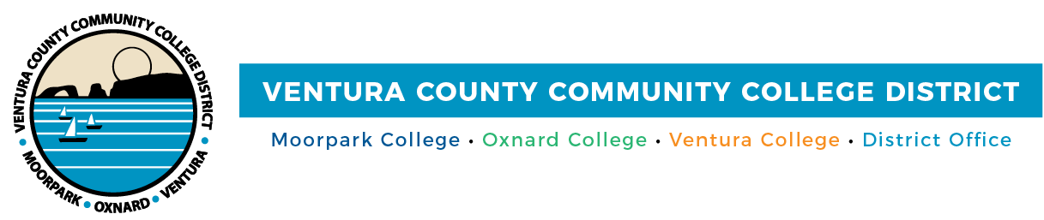

FOR IMMEDIATE RELEASE

Community Colleges of Ventura County Earn Innovation Honor from Ventura Chamber
Celebration affirms the District’s commitment to equity, innovation, and the future of Ventura County

Camarillo, Calif. (Nov. 26, 2025) — Big ideas are reshaping what’s possible for students and their future careers across Ventura County. At the 2025 Poinsettia Awards Luncheon, the Ventura County Community College District will be honored with this year’s Innovation Award. Presented by the Ventura Chamber of Commerce, this recognition highlights the ongoing work of the Community Colleges of Ventura County to advance student success and opportunity through forward-thinking pathways and transformative programs.
The annual Poinsettia Awards celebrates excellence in business, public service, and education, honoring individuals and organizations who are making a lasting difference in the Ventura community.
“To be honored by the Ventura Chamber of Commerce is a powerful affirmation that our work is making a real difference,” said Rick MacLennan, chancellor of the Community Colleges of Ventura County. “It tells us that the innovation happening across our colleges is not only visible: it’s valued, and it’s meeting the needs of the community we’re proud to serve every day.”
This recognition reflects initiatives from expanding dual enrollment opportunities for underrepresented students to building career pathways in fields like advanced manufacturing, healthcare, and cybersecurity. Through deep partnerships with local industry and civic organizations, these innovations are preparing students for the jobs of tomorrow while anchoring opportunity in the needs of Ventura County today.
“Innovation isn’t just about keeping up—it’s about lifting up,” said Gabriela Torres, Ventura County Community College District Board Chair. “By staying ahead of workforce trends and technology, our colleges are opening doors for students who’ve historically been left out. That’s what equity looks like in action, and we’re honored to do that work right here in the community we call home.”
Chancellor MacLennan will join other District leaders at the luncheon to accept the award and celebrate alongside fellow honorees, including the Ventura College Foundation, named Non-Profit of the Year, and Ventura College alum Sommer Frisk, recognized as the Shining Star of the Year.
To explore the programs and partnerships shaping student futures across Ventura County, visit vcccd.edu
About Ventura County Community College District
The Ventura County Community College District is a member of the 116-campus California Community College system and serves approximately 30,000 students annually. The District's three colleges—Moorpark, Oxnard and Ventura—offer programs in general education for degrees and certificates, transfer to four-year colleges and universities, career technical education and provide opportunities to engage in co-curricular campus activities. For more information, visit vcccd.edu.

Media Contact:
Outreach and Marketing
Ventura County Community College District
communications@vcccd.edu

