FOR IMMEDIATE RELEASE
VCCCD Announces Oxnard College Presidential Finalists
General Public invited to attend Open Forums to provide feedback on candidates
Oxnard, Calif. (Feb. 29, 2024) — Ventura County Community College District (VCCCD) Chancellor Rick MacLennan is pleased to announce that there are three (3) finalists moving forward in the search process for the next President of Oxnard College.
Listed below are candidate biographies and campus forums information. College faculty, staff, administration, and community members are invited to attend.
Oxnard College President Finalist Forums
Oxnard College Performing Arts Building
4000 South Rose Avenue, Oxnard, California
Monday, March 25, 2024
Dr. Roberto Gonzalez: 10:00 a.m. – 11:00 a.m. and 2:00 p.m. – 3:00 p.m.
Tuesday, March 26, 2024
Dr. Oscar Cobian: 10:00 a.m. – 11:00 a.m. and 2:00 p.m. – 3:00 p.m.
Thursday, March 28, 2024
Dr. Claudia Lourido-Habib: 10:00 a.m. – 11:00 a.m. and 2:00 p.m. – 3:00 p.m.
Public forums will take place the week of March 25, and each candidate will participate in two (2) open forums. We invite and encourage everyone to participate in the open forums. Each forum will be one (1) hour. Forums will be open to all faculty, administrators, staff, students, and the general public. There will be a brief introduction of each candidate, followed by a question-and-answer session. Forums will be conducted in-person in Oxnard College’s Performance Arts Building (PAB) Main Auditorium. All who attend will be asked to complete a feedback form.
We are looking forward to a successful completion of the presidential search process. If you have any questions or suggestions, please feel free to reach out to our ACCT Search Consultant, Julie Golder, ACCT Vice President of Search Services, at jgolder@acct.org or (202) 384-5816.
The Oxnard presidential finalists are (in alphabetical order):
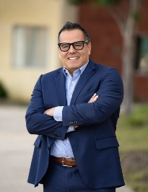
Oscar Cobian, Ed.D., is the current Interim President of Oxnard College, CA. Previously, Dr. Cobian served as the Vice President of Student Development at Oxnard College. Dr. Cobian earned a Doctorate in Higher Education Administration from the University of Southern California; Master of Science in Counseling and Guidance from California Lutheran University, CA; and a Bachelor of Arts in Spanish Language and Culture from California State University, Northridge, CA.

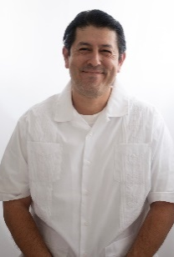
Roberto Gonzalez, Ed.D., is the current Vice President of Student Services, Enrollment Management, and Equity Initiatives at West Los Angeles College, Los Angeles Community College District, CA. Previously, Dr. Gonzalez served as a Dean at Santa Monica College in Santa Monica, California. Dr. Gonzalez earned a Doctorate of Education in Higher Education Administration from the University of Southern California; a Master of Science in Counseling from California State University, Long Beach; and a Bachelor of Arts in History from the University of California, Los Angeles.
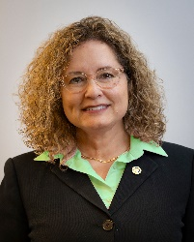
Claudia Lourido-Habib, Ed.D., is the current President of Porterville College, Kern Community College District, CA. Previously, Dr. Lourido-Habib served as the Vice President of Madera and Oakhurst Community College Centers, State Center Community College District, in Madera, California. Dr. Lourido-Habib earned a Doctorate in Education from California State University, Fresno, CA; a Master of Science in Instructional Technology from National University; and a Bachelor of Arts in Interior Design from California State University, Fresno.
About Oxnard College
Oxnard College is one of three colleges in the Ventura County Community College District and annually serves more than 7,000 students. Founded in 1975, Oxnard College is fully accredited. It is also a designated Hispanic-Serving Institution. Oxnard College’s signature programs include marine biology; culinary arts, restaurant management and hospitality management; auto technology, dental hygiene, and fire technology, among many other undergraduate study and career technical education programs. The Dream Resource Center is a valuable student and community resource. To learn more, visit oxnardcollege.edu and Facebook, Instagram, LinkedIn and Twitter.
About Ventura County Community College District
The Ventura County Community College District is a member of the 116-campus California Community College system and serves approximately 30,000 students annually. The District's three colleges—Moorpark, Oxnard and Ventura—offer programs in general education for degrees and certificates, transfer to four-year colleges and universities, career technical education and provide opportunities to engage in co-curricular campus activities. For more information, visit vcccd.edu.

