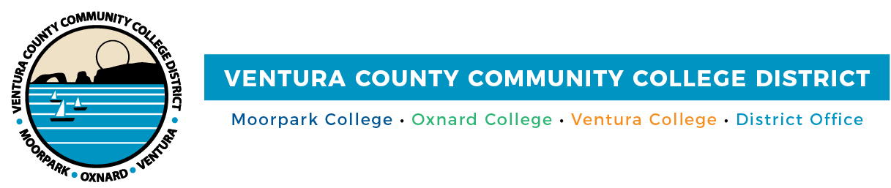

**FOR IMMEDIATE RELEASE**

**Community Colleges of Ventura County and VCOE Collaborate to Expand Educational Opportunities**

*Dual Enrollment programs bring college courses to high schools across the county*

**Camarillo, Calif.** (Sept. 23, 2024) — Educators from the Ventura County Community College District (VCCCD) and the Ventura County Office of Education (VCOE) gathered for a pivotal Community of Practice event at Ventura College on September 17. This collaborative meeting, entitled “Designing Equitable Dual Enrollment Pathways through Partnership,” brought together professionals from both systems to expand dual enrollment pathways in high schools.

With a focus on identifying courses that best meet the needs of local high school students and families, the event underscored the shared commitment to increasing access to higher education for all Ventura County’s students. These college courses, many of which can be embedded into the school schedule and held on the high school campus, provide an invaluable opportunity for students to earn credits while staying in their familiar school environment, at low to no cost.

“The Dual Enrollment Community of Practice has been an invaluable opportunity for collaboration,” said Melissa Johnson, VCCCD Director of Dual Enrollment. “By bringing together educators from both systems, we are not only strengthening our current programs but also identifying meaningful ways to expand access to college courses for high school students. We still have work to do, but the conversations today create a strong foundation for the future.”

Dual enrollment courses offered on high school campuses are a unique opportunity for students to take college-level classes at no cost, seamlessly integrated into their regular school day. These classes provide students with the chance to earn both high school and college credits without leaving campus or adjusting their schedules. Even better, the credits earned through these courses can transfer directly to programs at the Community Colleges of Ventura County, giving students a head start on their college education while still in high school.

“VCOE is excited to build on the success of year one of our Community of Practice, creating sustainable opportunities for meaningful engagement with our VCCCD educational partners,” said Lisa Salas Brown, VCOE Associate Superintendent. “Year two’s first convening brought together more than 100 participants, fostering collaboration, asking important questions, and expanding opportunities for our students to access college courses and dual enrollment programs across the county.”

For students and parents interested in learning more about dual enrollment opportunities, including how to enroll in college courses offered on their campus, contact your school counselor or visit [www.vcccd.edu/dual-enrollment](http://www.vcccd.edu/dual-enrollment).

**About Ventura County Community College District**

*The Ventura County Community College District is a member of the 116-campus California Community College system and serves approximately 30,000 students annually. The District's three colleges—Moorpark, Oxnard and Ventura—offer programs in general education for degrees and certificates, transfer to four-year colleges and universities, career technical education and provide opportunities to engage in co-curricular campus activities. For more information, visit* [*vcccd.edu*](http://www.vcccd.edu)*.*

**About Ventura County Office of Education**

*The Ventura County Office of Education (VCOE) is committed to expanding access to quality education for all. VCOE provides fiscal, training, and technology support services to local school districts, helping to maintain and improve lifelong educational opportunities. VCOE offers an extensive calendar of professional development and educational courses and seminars at a state-of-the-art conference center in Camarillo. They also operate schools that serve educationally disadvantaged students, provide career education programs, and coordinate countywide academic competitions.*

**Media Contact:**

Outreach and Marketing

Ventura County Community College District

[communications@vcccd.edu](mailto:communications@vcccd.edu)