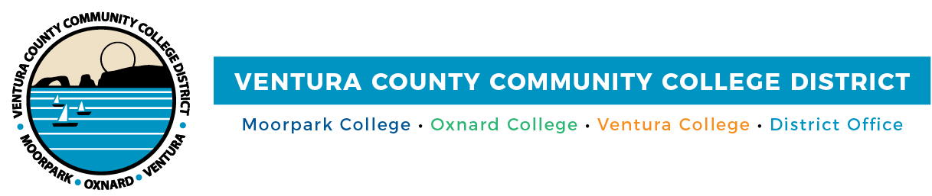

FOR IMMEDIATE RELEASE

Ventura County Community Colleges Launch Affordable Bachelor’s Degree Programs
Innovative four-year pathways meet regional workforce needs
Camarillo, Calif. (April 3, 2024) — Moorpark, Oxnard and Ventura colleges are proud to announce that all three institutions are launching applied baccalaureate degree programs on their campuses. As a part of the California Baccalaureate Degree Pilot Program, these first of their kind degrees offer the Ventura County community increased access to affordable career education that will prepare them for well-paying jobs in the region.
These four-year programs were designed to meet the specific workforce needs of the region that are not currently met by the local California State Universities. Moorpark College’s Bachelor of Science in Biomanufacturing, Ventura College’s Bachelor of Science in Automotive Career Education and Oxnard College’s Bachelor of Science in Dental Hygiene each will provide students with the knowledge and skills needed for high demand jobs within the changing, high technology industries in the county.
“The Community Colleges of Ventura County are responding to the evolving workforce needs by introducing new bachelor’s degrees," said Chancellor Rick MacLennan.
According to the state's Final Evaluation of the Community College Bachelor's Degree Pilot, 51% of students enrolled in a community college bachelor's degree program would not have otherwise pursued a bachelor’s education had it not been offered at their local community college. With the Ventura County community colleges’ upcoming program launches, these opportunities are extending to those students who may not have previously seen college in their futures. Through the Bachelor's Degree Pilot Program, tuition is capped at $130 per unit and $10,560 for the entire program—this means that many students who qualify for the College Promise program, state and federal aid and other financial aid options will now have another affordable path toward achieving academic success.
"The Baccalaureate Degree Pilot Program is a transformative, potentially life-changing step forward for our local community college students in Ventura County," remarked Board Chair Bernardo Perez. "This legislation empowers our community colleges to offer applied bachelor's degrees in high-demand fields that will meet the specific needs of our community and workforce."
Following the successful approval of their initial bachelor’s degree programs, the Ventura County community colleges continue to develop additional programs. Moorpark College’s proposed Bachelor of Science in Applied Cybersecurity & Network Operations is currently in review, and Oxnard College has recently submitted a new proposal for a Bachelor of Arts in Applied Advocacy & Organizing. As these diverse academic programs demonstrate, the Ventura County community colleges collectively strive to meet the future with innovation and inclusivity.
"Moorpark College is proud to lead the charge in offering a bachelor’s program to our county’s students, and we are eagerly looking forward to seeing the programs in Dental Hygiene at Oxnard College and Automotive Career Education at Ventura College come to fruition," said Dr. Julius Sokenu, president of Moorpark College. "Together, we're not just expanding educational opportunities; we're setting the stage for our students to excel in the careers of tomorrow."
Moorpark College is accepting students for the Bachelor of Science in Biomanufacturing program’s inaugural class in Fall 2024. To learn more about the Bachelor’s Degree Programs at the Ventura County community colleges, visit vcccd.edu/bachelorsdegree.
About Ventura County Community College District
The Ventura County Community College District is a member of the 116-campus California Community College system and serves approximately 30,000 students annually. The District's three colleges—Moorpark, Oxnard and Ventura—offer programs in general education for degrees and certificates, transfer to four-year colleges and universities, career technical education and provide opportunities to engage in co-curricular campus activities. For more information, visit vcccd.edu.

Media Contact:
Outreach and Marketing
Ventura County Community College District
communications@vcccd.edu

