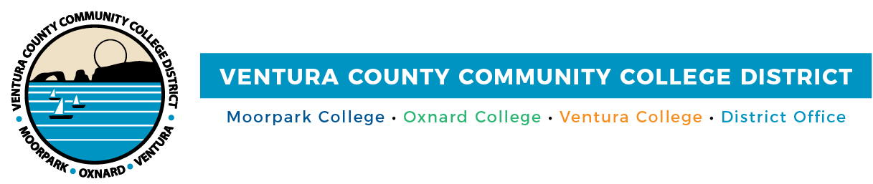

FOR IMMEDIATE RELEASE

Dual Enrollment Educators Forging Pathways for Ventura County Students
VCCCD and VCOE collaborate in second Dual Enrollment Community of Practice
Camarillo, Calif. (March 11, 2024) — The Ventura County Community College District (VCCCD) and the Ventura County Office of Education (VCOE) recently organized the second Dual Enrollment Community of Practice, emphasizing the importance of designing college pathways for high school students in Ventura County. Held on March 4, 2024, the workshop brought together educators and leaders from both school systems in a dynamic meeting of collaboration and inspiration.
The workshop, titled “Empowering Futures: Building Intentional Pathways for All Students,” highlighted the increasing opportunities available for the county’s high school students. These dual enrollment programs allow students to complete college-level courses while still in high school, providing them with a head start on their higher education journey. This event marked the continuation of efforts initiated during the first meeting in November 2023, where educators from both systems collaborated to envision dual enrollment opportunities across the county.
The ongoing collaboration between VCCCD and its K-12 partners underscores the commitment to advancing education and empowering students to pursue their academic and career goals.
“Community colleges are in the business of creating hope and opportunity. Dual enrollment experiences help all students realize that they are indeed college material,” said Dr. Rick MacLennan, Chancellor of the VCCCD.
Monday’s Community of Practice workshop was sponsored by the California Community College Chancellor’s Office and facilitated by Career Ladders Project, a California nonprofit organization specializing in equity-minded community college redesign processes. Participants discussed the importance of establishing clear and intentional pathways to provide a seamless transition from high school to college, enabling students to pursue higher education and career opportunities more quickly and at little-to-no cost. These discussions underscored the importance of tailored approaches to address the needs of varying student populations and help them overcome existing obstacles to access. Done strategically, dual enrollment can serve as both a powerful tool for student success and future workforce development.
“Implementing dual enrollment to meet equity goals for the students in our community will require a lot of hard work,” said Melissa Johnson, Program Director of Dual Enrollment at VCCCD. “There’s not a one size fits all solution—it will be school by school, college by college, and district by district, and we are committed.”
Through the Community of Practice event series, the VCCCD and VCOE are aligning with state-wide educational objectives. Vision 2030, California’s strategic plan for the community college system, sets the ambitious goal of 12+ units of college credit for every high school graduate. Such credit may not only count toward high school graduation but can also pave the way for career or apprenticeship pathways at local community colleges. By fostering an environment where any high school student can earn college credits tailored to their future careers, the VCCCD and VCOE are laying the groundwork for a future where dual enrollment is a cornerstone of educational equity and success.
A third Community of Practice event will be held later this year. For more information about dual enrollment in the Ventura County community colleges, please visit vcccd.edu/Dual-Enrollment or contact Melissa Johnson at mjohnson1@vcccd.edu.
About Ventura County Community College District
The Ventura County Community College District is a member of the 116-campus California Community College system and serves approximately 30,000 students annually. The District's three colleges—Moorpark, Oxnard and Ventura—offer programs in general education for degrees and certificates, transfer to four-year colleges and universities, career technical education and provide opportunities to engage in co-curricular campus activities. For more information, visit vcccd.edu.

Media Contact:
Outreach and Marketing
Ventura County Community College District
communications@vcccd.edu

