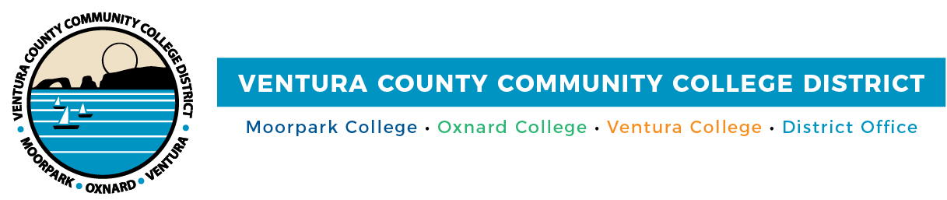

**FOR IMMEDIATE RELEASE**

**VCCCD Celebrates LGBTQIA+ Students at Second Annual Lavender Graduation**

*Moorpark, Oxnard, and Ventura colleges’ students honored at celebration*

**Camarillo, Calif.** (May 2, 2024) — Building on the success of last year's inaugural celebration, the Community Colleges of Ventura County proudly hosted the second annual Lavender Graduation on April 26, 2024, at Moorpark College. The districtwide ceremony was open to all students identifying as LGBTQIA+ who attend Moorpark, Oxnard, and Ventura colleges and Ventura College East Campus. Family, friends, and other supporters were invited as well.

This year's event was a sincere showcase of diversity and empowerment. The ceremony featured addresses from all three college presidents and inspiring speeches by three student speakers from each college, which underscored themes of resilience, inclusivity, and the importance of embracing one's personal identity.

"Each story I heard was a testament to the resilience and strength of our students," said Bernardo M. Perez, Board Chair. "Their candid reflections on struggle and success deeply moved me and highlighted the importance of recognizing the multifaceted achievements of our graduates—not just academic, but also the personal victories that define their unique and valuable identities."

In a meaningful continuation of tradition, District employees from each of the colleges presented the graduating students with lavender stoles, emblematic of empowerment and pride within the LGBTQIA+ community. Additionally, students and employees received recognition for their exemplary leadership, steadfast advocacy, inspirational contributions, and supportive allyship.

“Visibility matters,” shared Julius Sokenu, president of Moorpark College, in his opening remarks at the event. “The fact that we are here celebrating our graduates means we are making space for traditions that will become part of the culture of the Community Colleges of Ventura County—that is equity, and that is true representation.”

Lavender Graduation, first held in 1995 to acknowledge the accomplishments of LGBTQIA+ students, has become a vital tradition celebrating inclusivity and diversity in academia. The ceremony stands as a heartfelt celebration that intertwines personal triumph and self-expression, affirming the importance of each student’s achievements and the courage to live authentically.

“Our LGBTQIA+ students' achievements and dedication greatly enrich our academic community, and we are proud to recognize and celebrate their successes,” said Rick MacLennan, Chancellor.

The Ventura County Community College District prioritizes the support and inclusion of LGBTQIA+ students throughout the year. Some of these efforts include LGBTQIA+ scholarships, support groups, campus clubs, mental health services, Pride events, employee trainings, and partnerships with community organizations such as Ventura County Diversity Collective, among others.

For more information about Lavender Graduation, [visit the LGBTQIA+ webpage](https://www.vcccd.edu/students/lgbtq).

**About Ventura County Community College District**

*The Ventura County Community College District is a member of the 116-campus California Community College system and serves approximately 30,000 students annually. The District's three colleges—Moorpark, Oxnard and Ventura—offer programs in general education for degrees and certificates, transfer to four-year colleges and universities, career technical education and provide opportunities to engage in co-curricular campus activities. For more information, visit* [*vcccd.edu*](http://www.vcccd.edu)*.*

**Media Contact:**

Outreach and Marketing

Ventura County Community College District

[communications@vcccd.edu](mailto:communications@vcccd.edu)