FOR IMMEDIATE RELEASE
The Community Colleges of Ventura County Announce Selection of Two New College Presidents
Camarillo, Calif. (April 17, 2024) — Following a nationwide search and the approval of the VCCCD Board of Trustees, Chancellor Dr. Rick MacLennan is excited to announce the selection of Dr. Roberto Gonzalez for the position of President, Oxnard College and Dr. Claudia Lourido-Habib for President, Ventura College.
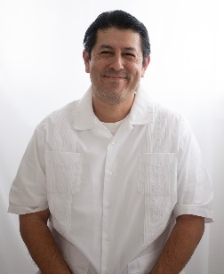
With expertise in both student services and academic affairs, Dr. Gonzalez is recognized as an inclusive, equity-minded leader prioritizing the student experience. Chancellor MacLennan remarks, “Dr. Gonzalez is celebrated as a student-focused leader,” emphasizing his commitment to meeting diverse student needs. Dr. Gonzalez is also expected to officially begin his role on July 1, 2024.

“I am deeply honored and humbled to have been selected to lead Oxnard College,” said Dr. Gonzalez. “I look forward to serving all the members of our community including students, faculty, classified professionals and administrators. I am eager to play a role in enhancing the outstanding academic programs, academic and student services and resources we provide to our students.”
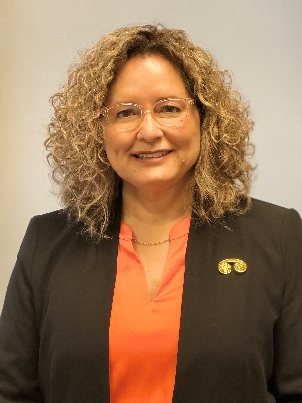
With a commitment to enhancing students’ social and economic mobility through higher education, Dr. Lourido-Habib epitomizes the core mission of community colleges, being herself a first-generation community college graduate. Chancellor MacLennan notes, “Dr. Lourido-Habib is highly recognized as a collaborative and visible leader,” praising her community engagement and her fierce advocacy for celebrating and supporting all students. She is set to officially assume her role on July 8, 2024.

“I am excited about the opportunity to join the Ventura County Community College District,” said Dr. Lourido-Habib. “I am eager to collaborate with the administrative team, faculty, classified professionals and community members to build upon Ventura College's legacy of excellence and to provide transformative educational opportunities to students.”
The hiring process for these positions included a thorough national search conducted by ACCT Search Consultants. Candidates were interviewed by diverse screening committees comprised of students, community members, faculty, classified professionals and administrators. The campus community and public were invited to meet the finalists at open forums that were held on each college campus. Following these forums, each finalist was given a tour of the college and then interviewed by the Chancellor.
On behalf of the Community Colleges of Ventura County, Chancellor MacLennan and the Board of Trustees extend their heartfelt gratitude to Dr. Oscar Cobian for his outstanding dedication and leadership during his tenure as Interim President of Oxnard College. Over the last two years, Dr. Cobian has led Oxnard College with poise and integrity. We are profoundly grateful for Dr. Cobian’s service and thank him for his continued leadership.
About Dr. Roberto Gonzalez, Ed.D.
Dr. Gonzalez currently serves as the Vice President of Student Services, Enrollment Management, and Equity Initiatives at West Los Angeles College, Los Angeles Community College District, CA. Dr. Gonzalez holds a Doctorate of Education in Higher Education Administration from the University of Southern California; a Master of Science in Counseling from California State University, Long Beach; and a Bachelor of Arts in History from the University of California, Los Angeles. With over 25 years of experience in higher education, Dr. Gonzalez has dedicated himself to empowering students and fostering equitable access to education. His personal journey, rooted in immigrant parents’ aspirations for a better future, underscores his passion for education and commitment to serving students within the California Community College System.
About Dr. Claudia Lourido-Habib, Ed.D.
Dr. Lourido-Habib currently serves as the President of Porterville College, Kern Community College District, CA. Her educational background includes a Doctorate in Education from California State University, Fresno, CA; a Master of Science in Instructional Technology from National University; and a Bachelor of Arts in Interior Design from California State University, Fresno. With over two decades of experience in community colleges, she has demonstrated a steadfast dedication to expanding access to higher education and fostering innovative programs for traditionally underserved populations.
About Ventura County Community College District
The Ventura County Community College District is a member of the 116-campus California Community College system and serves approximately 30,000 students annually. The District's three colleges—Moorpark, Oxnard and Ventura—offer programs in general education for degrees and certificates, transfer to four-year colleges and universities, career technical education and provide opportunities to engage in co-curricular campus activities. For more information, visit vcccd.edu.
Media Contact:
Outreach and Marketing
Ventura County Community College District
communications@vcccd.edu

