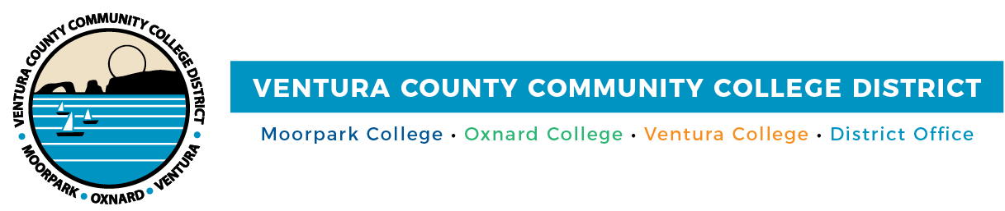

FOR IMMEDIATE RELEASE

VCCCD Celebrates Class of 2023 Graduates
Moorpark, Oxnard and Ventura Colleges’ students honored

Camarillo, Calif. (May 22, 2023) — On Friday, May 19, 5,283 students from across the Ventura County Community College District were celebrated for their accomplishments during commencement ceremonies held at Moorpark, Oxnard and Ventura colleges.

Among the colleges’ cohorts, the class of 2023 earned 7,321 associate degrees and 4,467 certificates. Many VCCCD students earn multiple degrees and certificates when they graduate, taking with them skills and expertise as they launch their careers or transfer to four-year institutions.

“I commend all of our graduates for the perseverance and hard work it took to reach this impressive milestone,” said Chancellor Rick MacLennan. “Commencement is a wonderful tradition that simultaneously celebrates academic achievement and marks the beginning of a new journey. I wish each of our graduates the very best wherever their next pursuits may lead them. We are all proud and delighted to have been a part of their journey.”

“I celebrate and congratulate you students upon reaching this milestone along your educational and/or career pathway,” Chair Bernardo Perez shared with graduates in his commencement address. “You bring to life all the hopes and dreams your parents and family hold for you. You fulfill the potential your professors and counselors saw in you. You are on your way to achieving your life dreams and plans.”

After the ceremonies, the college presidents shared their pride and well wishes for the graduates’ futures:

"We encourage our graduates to embrace the future with open arms and a bold spirit,” said Julius Sokenu, president of Moorpark College. “As you carry on in your journey, remember that success is not merely defined by achievements or milestones, but by the lives you touch, the communities you uplift, and the positive change you bring to the world. Here’s to the Class of 2023!"

“Oxnard College’s graduating class is filled with accomplished students who are determined to build better lives for themselves and their families,” said Dr. Oscar Cobian, interim president of Oxnard College. “As our graduates transfer to four-year universities and enter rewarding careers, we know they will leave their mark on Ventura County and our state for many years to come.”

“As the college president, there is no greater joy than witnessing the culmination of years of hard work and dedication on graduation day,” said Kim Hoffmans, president of Ventura College. “With a remarkable total of 2,108 Pirate graduates, I am confident that their accomplishments will continue to inspire their loved ones and create a lasting positive impact on our community.”
About Ventura County Community College District

The Ventura County Community College District is a member of the 116-campus California Community College system and serves approximately 30,000 students annually. The District's three colleges—Moorpark, Oxnard and Ventura—offer programs in general education for degrees and certificates, transfer to four-year colleges and universities, career technical education and provide opportunities to engage in co-curricular campus activities. For more information, visit vcccd.edu.

Media Contact:
Public Affairs and Marketing
Ventura County Community College District
communications@vcccd.edu

