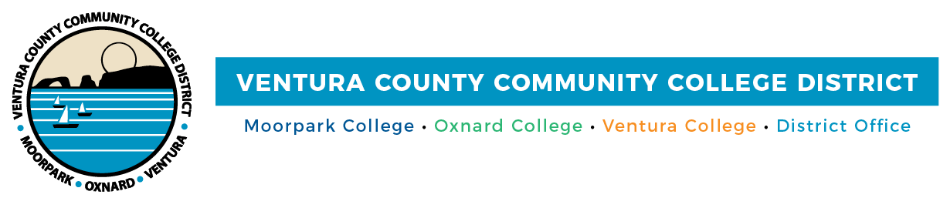

FOR IMMEDIATE RELEASE

VCCCD Makes It Happen with Statewide Marketing Awards
Outreach and Marketing department receives three honors

Camarillo, Calif. (May 3, 2023)—The marketing tagline "Ventura County Community Colleges Make it Happen” succinctly showcases how Moorpark, Oxnard and Ventura colleges help students obtain critical skills to transfer to a four-year university or launch their careers. The marketing campaign built around the tagline earned VCCCD’s Outreach and Marketing department three awards from the Community Colleges Public Relations Organization (CCPRO), a professional development and service organization that promotes excellence in California’s community college public relations and related professions.

VCCCD was honored with the following awards, which were announced at CCPRO’s annual conference in April:
- Bronze: “Ventura County Community Colleges Make it Happen” programs flyer used for community outreach activities.
- Silver: 2022 virtual yearbook websites highlighting the graduates of Moorpark, Oxnard and Ventura colleges.
- Gold: “Ventura County Community Colleges Make it Happen” presentation folder.

The VCCCD Outreach and Marketing department includes Marketing, Communications and Web Design coordinators Allie Frazier, Alexander Rock Fredell and Diana Martin.

“These accolades are a reflection of our team's dedication to creativity, innovation and excellence in delivering effective outreach and marketing campaigns to promote VCCCD's mission and programs,” said Martin. “We are proud to be recognized for our digital and physical collateral work and remain committed to advancing VCCCD's initiatives to support student success and community engagement."

This is the second time the virtual yearbooks received CCPRO honors. In 2021, the Outreach and Marketing department received a gold award for the virtual yearbooks, which were created as a way to honor the 2020 graduates when in-person commencement ceremonies were canceled due to the COVID pandemic.

Ventura County Community College District
The Ventura County Community College District is a member of the 116-campus California Community College system and serves approximately 30,000 students annually. The District's three colleges--Moorpark, Oxnard and Ventura--offer programs in general education for degrees and certificates, transfer to four-year colleges and universities, career technical education, and provide opportunities to engage in co-curricular campus activities. For more information, please visit vcccd.edu.

Media Contact:
Outreach and Marketing
Ventura County Community College District
communications@vcccd.edu

