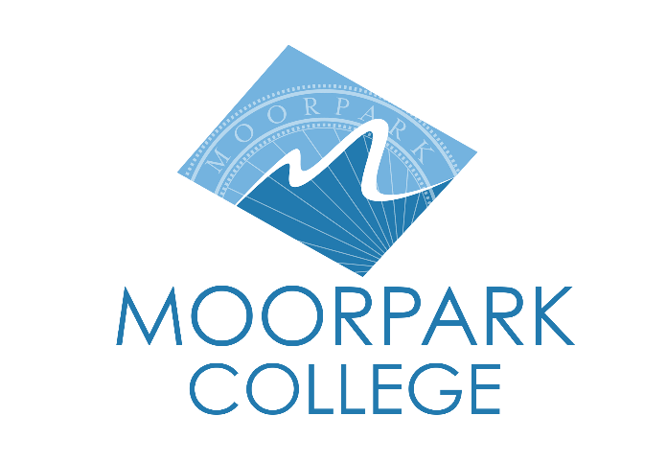 | Moorpark College  7075 Campus Road  Moorpark, CA 93021  805.378.1400  moorparkcollege.edu
For Immediate Release

Announcing Auditions for Moorpark College’s Summer Theatre Production
of the Award-Winning Musical “Cabaret”

Moorpark, Calif. (May 1, 2023)—Moorpark College is excited to announce auditions for its Summer Theatre Arts production of the classic musical “Cabaret.” Auditions will be May 8-10 in the Performing Arts Center on the Moorpark College campus. Dance auditions will be May 8, 3:30-6 p.m., and singing auditions will be May 9, 6-10 p.m. Final callbacks will be May 10, 6-10 p.m.

Anyone interested in auditioning should wear comfortable clothing, be prepared to sing 30 bars (1 minute) of a song from a theatrical musical, preferably by the composer/lyricist team of John Kander and Fred Ebb, and be ready to read from the script. An accompanist will be present for the audition.

Set in a nightclub in Berlin at the end of the 1920s, “Cabaret” explores the dark, heady and tumultuous life of Berlin's natives and expatriates as Germany slowly yields to the emerging Third Reich. The story revolves around Cliff, a young American writer newly arrived in Berlin, who is immediately taken with English singer Sally Bowles. Meanwhile, Fräulein Schneider, proprietor of Cliff and Sally's boarding house, tentatively begins a romance with Herr Schultz, a mild-mannered fruit seller who happens to be Jewish. This powerful and darkly comic American musical explores themes of love, political intrigue and the consequences of intolerance. Musical numbers include "Willkommen," "Cabaret," "Don't Tell Mama" and "Two Ladies," to name a few.

“We are very excited to be bringing big musicals back to our Summer stage,” said John Loprieno, director and theatre arts faculty member. “Our Summer program has always been designed to be an on-ramp for incoming students who will be attending Moorpark College for the first time in the fall. As our Dual Enrollment efforts continue to grow throughout the community, high school students across our service area have already started to accumulate credits at our college through online offerings. This is a wonderful opportunity to have them come to our campus to experience all it has to offer.”

“Cabaret” runs July 20–Aug. 6, Thursdays–Saturdays at 8 p.m. and Sundays at 2 p.m. in the Studio Theatre in the Moorpark College Performing Arts Center. Seating is limited for these performances, and tickets can be purchased through the Moorpark College Performing Arts Center Box Office at (805) 378-1485 or online at www.moorparkcollege.edu/pac. Moorpark College is located at 7075 Campus Road, Moorpark.

About Moorpark College
Moorpark College Mission
Grounded in equity, social justice, and a student’s first philosophy, Moorpark College values diverse communities. We empower learners from local, national, and global backgrounds to complete their degree, certificate, transfer, and career education goals. Through innovation and customized student support, our programs are designed to achieve equitable outcomes.

Moorpark College is one of three colleges in the Ventura County Community College District and annually serves more than 14,000 students. Founded in 1967, Moorpark College is fully accredited and has the highest six-year completion rate within the California Community College System. An Aspen Institute Top 4 Finalist for 2023, Moorpark College has also been named a 2020 Champion of Higher Education by The Campaign for College Opportunity for the Associate Degree for Transfer Pathway. It is also a designated Hispanic-Serving Institution. The college’s signature career/technical programs include nursing, radiologic technology, biotechnology and journalism. The college’s America’s Teaching Zoo is the only associate degree exotic animal training program in the country. To learn more, visit MoorparkCollege.edu or follow @MoorparkCollege on social media.

Media Contacts:
Jamie Whittington-Studer
Public Information Officer
Moorpark College
jamie_whittingtonst1@vcccd.edu

John Loprieno
Director and Theatre Arts Faculty
Moorpark College
(805) 378-1469
JLoprieno@vcccd.edu

