FOR IMMEDIATE RELEASE
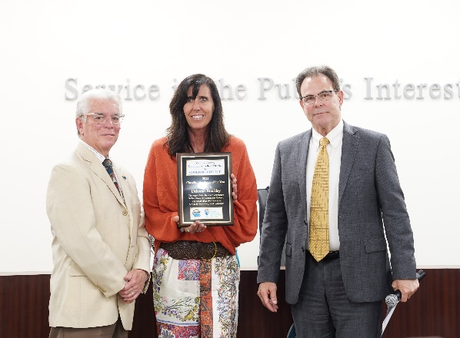
(From left) Board Chair Bernardo M. Perez, Deborah Brackley
and Chancellor Rick MacLennan

Classified Employee Honorees Recognized at VCCCD Board Meeting
Board of trustees also acknowledged Chair Bernardo M. Perez’s service

Camarillo, Calif. (April 28, 2023)—As the tutoring and supplemental support supervisor at Moorpark College, Deborah (Deb) Brackley ensures students have the tools they need to succeed. She is also involved in the campus community and finds opportunities for programs to support equity work. For these reasons and more, Brackley was named the Ventura County Community College District (VCCCD) 2023 Classified Employee of the Year at the April board of trustees meeting. The annual award is a tribute to classified professionals who demonstrate professional ethics and standards and serve the community with purpose and passion.

The board also presented Board Chair Bernardo M. Perez with a resolution honoring his 12 years of service. Moorpark College President Julius Sokenu recognized Linda Resendiz, executive assistant to the president, who received the 2023 California Community College Classified Senate President Service Award. (Resendiz will be formally recognized at the June meeting after being honored by the state organization on June 8.)

“As a longtime trustee, I have consistently witnessed a high level of caring and excellence throughout the District’s classified employees. I would like to thank this year’s honorees and Linda, who has been a dedicated District employee for 15 years,” said Perez. “I appreciate the resolution from the board of trustees for my service; it’s a privilege to work with this board.”

“Classified employees at Moorpark, Oxnard and Ventura colleges and the District Administrative Center are the backbone of our commitment to serving our students,” said Chancellor Rick MacLennan. “And it’s wonderful to see each of these exemplary employees receive this well-deserved recognition.”

“Trustee Perez is widely respected throughout the District as a visible and highly engaged advocate for our mission and student success,” MacLennan added, speaking of the resolution honoring Perez. “Acknowledgement of his service and impact by the board of trustees is very meaningful.”

The District awards the Classified Employee of the Year distinction in accordance with the California Community Colleges (CCC) Board of Governors, which will consider Brackley for the CCC statewide award. At the May 2023 Board of Governors meeting, up to six recipients will be named California Community Colleges Classified Employee of the Year. Winners receive a $750 cash award and a plaque.

Additional VCCCD Classified Employee of the Year nominees included Karina Harding, District Administrative Center; Amanda Burwick, Oxnard College; and Jordan Goebel, Ventura College.

About the Honorees

Harding is a purchasing specialist with a commitment to high-performance standards and has a positive outlook when it comes to the leadership role in the purchasing department at the District Administrative Center. She is skilled at organizing others within the work environment, promotes open communication within the department and is always willing to help her colleagues. In her nomination, Harding was commended for being a “working machine,” professional and approachable.

Brackley has a commitment to excellence and focuses on doing her best for the Tutoring and Learning Center and Moorpark College. She collaborates with the Library staff, the First/Second Year Experience programs, CHESS, STEM Impacto, ACCESS and athletics. She also uses the resources of the tutoring center to support these programs. Brackley wrote culturally competent outcomes for tutors and created a cultural competence component to the tutoring training, co-led the college’s social justice work group and created and delivered a presentation during Flex Week training for staff, faculty, students and administrators.

Oxnard College students describe Burwick as helpful, agreeable, dependable, outgoing, professional and humble. She works to transform students’ lives by offering equitable access to multiple educational and career pathways. As the job placement specialist, she works to understand job trends, build strong relationships with community partners to create hands-on learning internship opportunities and has created innovative programming to support student needs. Under her leadership, the campus has annually hosted over 70 employers interested in recruiting OC students, four student worker job fairs, the LA Rams HR Director and the Port of Hueneme. Burwick is also engaged in leadership positions across various college committees and senates where she regularly advocates for employees and students.

Goebel, an information technology support specialist II, is described as one of the most genuine, honest and gentle souls around. He works tirelessly for Ventura College and is dedicated to student access, success and the best possible campus technology operations. His commitment to the campus community is unparalleled, and he is integral to the success of the college’s IT operations. As a contributing member of the graduation committee, he proposed, coordinated and managed the Eventbrite ticketing system, which made it easier for graduates’ families and friends to attend and celebrate their graduates' scholastic achievements.

Prior to her current position, Resendiz was the senior administrative assistant to the executive vice presidents at Ventura College and Moorpark College. She was the classified senate vice president at Moorpark College before becoming the president three years ago. At Ventura College, she was the classified senate treasurer. Being in a leadership role has been a great growth experience, she said.

“Encouraging my fellow classified professionals to be participants in college-wide decision-making has been a priority for me. I deeply care for our classified voice involving important matters and believe that our roles as leaders on our campuses are necessary and important,” said Resendiz.

Representing Area 4, Perez joined the VCCCD board of trustees in 2010 and has held leadership roles multiple times. Previously, he represented his community on the Moorpark City Council, including serving as Moorpark’s mayor. He has held positions with the Workforce Investment Board, Moorpark Foundation for the Arts and Simi Valley Hospital Foundation. Perez worked as the project manager for the Cabrillo Economic Development Corporation in Ventura and was employed with the Los Angeles Department of Water and Power for over 30 years.
Ventura County Community College District
The Ventura County Community College District is a member of the 116-campus California Community College system and serves approximately 30,000 students annually. The District's three colleges--Moorpark, Oxnard and Ventura--offer programs in general education for degrees and certificates, transfer to four-year colleges and universities, career technical education, and provide opportunities to engage in co-curricular campus activities. For more information, please visit vcccd.edu.

Media Contact:
Marketing and Outreach
Ventura County Community College District
communications@vcccd.edu

