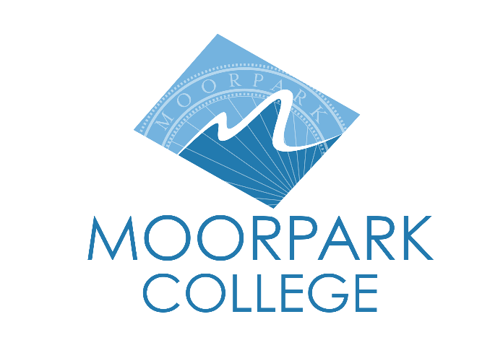 | Moorpark College  7075 Campus Road  Moorpark, CA 93021  805.378.1400  moorparkcollege.edu
For Immediate Release

“The Tempest” Makes Landfall at Moorpark College Theatre Arts

Moorpark, Calif. (March 7, 2023) — Shakespeare’s “The Tempest” arrives March 16 on the Moorpark College Performing Arts Center main stage, filled with comedy, magic, love and treachery. The student production runs through March 25 with evening performances and weekend matinees.

This comedic fantasy will honor the 10-year anniversary of the Elizabethan-style set theatre arts instructor Brian Koehler designed for the productions of “Henry IV, Part I” and “Part II” in 2013.

“The base design of our Shakespearean set takes inspiration from the Globe Theatre in England,” said Koehler, scenic designer of “The Tempest.”

“This style of stage becomes a classic theatrical component in and of itself, with show-specific elements that largely rely on the dialogue of the production to delineate space and detail. It provides a multi-layered production experience for our students, both technicians and performers. Even with something as crazy as ‘The Tempest,’ it is about embracing the traditional structure versus hiding it," he explained.

“The Tempest” tells the story of Prospero, who uses his magic to conjure a storm and torment shipwreck survivors, including the King of Naples and Prospero’s treacherous brother, Antonio. Prospero’s servant, the half-man, half-beast Caliban, plots to rid himself of Prospero’s servitude but is thwarted by Prospero’s magical spirit-ally, Ariel. The King’s young son, Ferdinand, thought to be killed in the storm, falls in love with Prospero’s daughter, Miranda. Their celebrations are cut short when Prospero confronts his brother and reveals his identity as the usurped Duke of Milan.

As with all Shakespearean comedies, the families are reunited, and all conflict is resolved in a highly romantic and entertaining fashion.

“The Tempest” runs March 16-18 and March 23-25 at 8 p.m., with 2 p.m. matinees on March 19 and 25 on the main stage of the Moorpark College Performing Arts Center. The evening performances on March 17 and 25 will be accompanied by ASL interpreters.

Tickets are on sale now and can be purchased through the Moorpark College Performing Arts Center Box Office at (805) 378-1485 or online at moorparkcollege.edu/pac. Tickets are $15 for students and seniors, and $20 for adults. There is a 20% discount for purchasing tickets online in advance. Moorpark College is located at 7075 Campus Road, Moorpark.

###

About Moorpark College
Moorpark College Mission
Grounded in equity, social justice, and a student’s first philosophy, Moorpark College values diverse communities. We empower learners from local, national, and global backgrounds to complete their degree, certificate, transfer, and career education goals. Through innovation and customized student support, our programs are designed to achieve equitable outcomes.

Moorpark College is one of three colleges in the Ventura County Community College District and annually serves more than 14,000 students. Founded in 1967, Moorpark College is fully accredited and has the highest six-year completion rate within the California Community College System. An Aspen Institute Top 10 Finalist for 2023, Moorpark College has also been named a 2020 Champion of Higher Education by The Campaign for College Opportunity for the Associate Degree for Transfer Pathway. It is also a designated Hispanic-Serving Institution. The college’s signature career/technical programs include nursing, radiologic technology, biotechnology and journalism. The college’s America’s Teaching Zoo is the only associate degree exotic animal training program in the country. To learn more, visit MoorparkCollege.edu or follow @MoorparkCollege on social media.

Media Contact:
Jamie Whittington-Studer
Public Information Officer
Moorpark College
jamie_whittingtonst1@vcccd.edu

