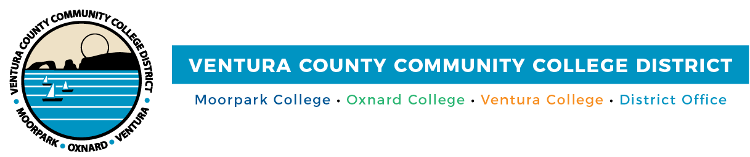

FOR IMMEDIATE RELEASE

Weekday Evening Cash 4 College Workshops Added
at Ventura County Community Colleges
November workshops will assist students in accessing funds for college

(CAMARILLO, Calif.) October 20, 2022 — Moorpark College, Oxnard College, Ventura College and Ventura College East Campus are holding free evening Cash 4 College workshops to help students apply for funds to help with college costs. Funds can be used for tuition, books, housing, transportation, childcare, computers and more.

In-person and online Zoom workshops are scheduled for Nov. 8 and 15, depending on the campus. The workshops are free and open to the community; anyone may attend a workshop on either date and can drop in at any time during the events.

Bilingual financial aid staff will assist students in completing applications for the 2023-2024 school-year Free Application for Federal Student Aid (FAFSA) or the California Dream Act Application (CADAA). Students can also access information about basic needs support (food, clothing and housing assistance), tutoring, academic counseling, mental health services and other student services.
AB 469 now requires school districts to confirm seniors have completed the FAFSA or California Dream Act Application before graduating in 2023. Cash for College events can help students get ahead.
For more information, visit vcccd.edu/cash4college.

Moorpark College
Online
Nov. 8
Nov. 15
5 p.m. – 7 p.m.
Zoom Link: https://bit.ly/MC-Cash4College
For info: Contact the Moorpark College Financial Aid Office at (805) 378-1462 or mcfa@vcccd.edu.

Oxnard College
Online and In-Person
Nov. 8
Nov. 15
5 p.m. – 7 p.m.
Oxnard College Student Services Building
4000 S. Rose Ave., Oxnard
Zoom link: https://bit.ly/OC-Cash4College
For info: Contact the Oxnard College Financial Aid Office at (805) 678-5828 or ocfinaid@vcccd.edu.

Ventura College
In-Person
Nov. 8
Ventura College Learning Resource Center
4667 Telegraph Road, Ventura

Ventura College East Campus
In-Person
Nov. 15
5 p.m. – 7 p.m.
957 Faulkner Road, Unit 106, Santa Paula
For info: Contact the Ventura College and Ventura College East Campus Financial Aid Office at
(805) 289-6369 or vcfinancialaid@vcccd.edu.

About Ventura County Community College District
The Ventura County Community College District is a member of the 116-campus California Community College system and serves approximately 30,000 students annually. The District's three colleges — Moorpark, Oxnard and Ventura — offer programs in general education for degrees and certificates, transfer to four-year colleges and universities, career technical education and provide opportunities to engage in co-curricular campus activities. For more information, visit www.vcccd.edu.

Media Contact:
Patti Blair
Director, Public Affairs and Marketing
Ventura County Community College District
communications@vcccd.edu

