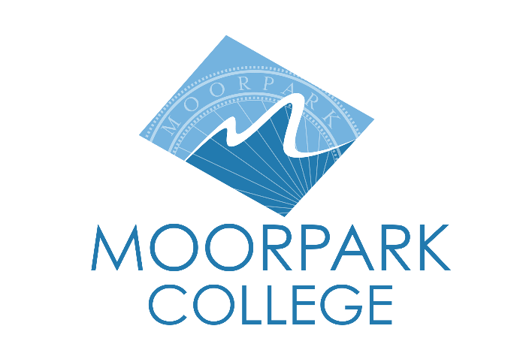 | Moorpark College  7075 Campus Road  Moorpark, CA 93021  805.378.1400  moorparkcollege.edu
For Immediate Release
Moorpark College Partners with National Centers for Inquiry and Improvement
on Student Financial Stability Initiatives
Moorpark student financial stability profile featured on NCII website
Moorpark, Calif. (November 7, 2022) — To address barriers impacting students’ success, Moorpark College partnered with the National Center for Inquiry and Improvement (NCII) to conduct an exhaustive, two-year Student Financial Stability Study. NCII, which helps community colleges enhance outcomes for underserved students, partnered with colleges nationwide that prioritize students’ financial stability. Moorpark College was one of seven to be featured on the NCII website for its plan of action based on the survey results.
Participation in this study also included a $1,000 donation to the Moorpark College Foundation for student scholarships.
Through surveys and interviews with stakeholders, the colleges gained insight into areas of growth and developed strategies to support students. Profiles of the featured institutions demonstrate how each has changed its practices and policies to ensure more students can cover college costs, meet their basic needs, and choose education and career goals that lead to long-term social and economic mobility.
Pre-COVID-19, surveys revealed significant food and housing insecurity among Moorpark College’s students, galvanizing the college to have difficult conversations identifying whom it serves and what students need to succeed. As COVID-19 evolves, the college will continue addressing these issues while preparing students effectively.
“People come to our colleges to develop their careers and reach their dreams,” said Rick MacLennan, chancellor of the Ventura County Community College District. “Moorpark College is doing the vital work of considering our students’ needs on and off campus. When students receive holistic support, they are prepared to come to class and thrive.”
Even with a relatively high completion rate, Moorpark has used the study data to focus its support for the 36% of students who do not complete on time. By integrating the Educational Master Plan into a robust data-informed decision-making process, the college heavily invests in professional development and focuses on students’ cultural and economic needs. Examples of this include a year-long orientation for new personnel and a week-long professional development program to promote the college’s culture of centering on student success and the importance of supporting the whole student.
“At the heart of our work is the belief that we're equipping people for life,” said Julius Sokenu, president of Moorpark College. “Whether we're providing students pathways to career success or building skill sets and habits they can take from the classroom to their lives as members of a community, Moorpark College can model behaviors that build community success and capacity.”
The college also integrates basic needs assistance and financial literacy efforts into all student equity initiatives and grant-funded programs and activities. For example, programs such as Project STEM Impacto and Attract, Inspire, Mentor, and Support Students (AIMS2) include economic support for participants, such as book vouchers and relevant paid work experience.
Moorpark College’s Student Financial Stability Report is available at ncii-improve.com/student-financial-stability/student-financial-stability-college-profile-series. For more information on the Basic Needs Center at Moorpark College or the Moorpark College Foundation, visit moorparkcollege.edu/community/foundation.
About Moorpark College
Moorpark College Mission
Grounded in equity, social justice, and a student’s first philosophy, Moorpark College values diverse communities. We empower learners from local, national, and global backgrounds to complete their degree, certificate, transfer, and career education goals. Through innovation and customized student support, our programs are designed to achieve equitable outcomes.

Moorpark College is one of three colleges in the Ventura County Community College District and annually serves more than 14,000 students. Founded in 1967, Moorpark College is fully accredited and has the highest six-year completion rate within the California Community College System. An Aspen Institute Top 10 Finalist for 2023, Moorpark College has also been named a 2020 Champion of Higher Education by The Campaign for College Opportunity for the Associate Degree for Transfer Pathway. It is also a designated Hispanic-Serving Institution. The college’s signature career/technical programs include nursing, radiologic technology, biotechnology and journalism. The college’s America’s Teaching Zoo is the only associate degree exotic animal training program in the country. To learn more, visit MoorparkCollege.edu or follow @MoorparkCollege on social media.
Media Contact:
John Loprieno
jloprieno@vcccd.edu
(805) 378-1469

