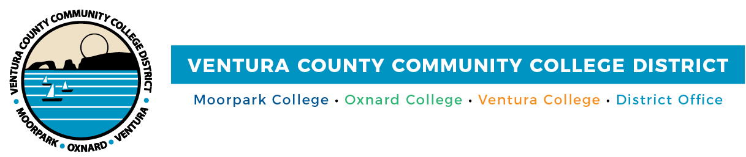

FOR IMMEDIATE RELEASE

Action Week Focuses on Working Together to Support Undocumented College Students
VCCCD joins California Community Colleges in supporting and celebrating
state’s undocumented students

Camarillo, Calif. (September 30, 2022) — Approximately 75,000 undocumented students are enrolled in California public and independent colleges and universities, according to the California Undocumented Higher Education Coalition. To assist these students in their journey, the Ventura County Community College District joins California Community Colleges and statewide partners for the sixth annual Undocumented Student Action Week (USAW), Oct. 17-21.
This year’s theme is “Juntos Podemos (Together, We Can): Collaborative Ecosystems that Support Undocumented Students.” During USAW, Moorpark, Oxnard and Ventura colleges will focus on advancing best practices, ensuring authentic, campuswide collaboration and advocating for policy solutions to support long-term success.
Ventura County community colleges will also raise awareness of student support services tailored to undocumented students’ needs. The District and colleges will hold in-person events and virtual webinars that address challenges students continue to face, share actionable solutions and celebrate cultural diversity. Events include financial aid and informational workshops on career development, mental health and scholarships, among others. There will also be art activities and a game day.
During USAW and throughout the academic year, students will have access to immigration legal services providers for free, confidential immigration consultations, eligibility screenings, case management services and educational resources.
“Ventura County community colleges are welcoming and safe places for undocumented students, no matter where they are from,” said Board Chair Dianne McKay. “Supporting students in achieving their education and career goals benefits not only the students and their families but also enhances the economic vitality of our county.”
“Diversity, equity and inclusion are paramount to our District. While we celebrate Undocumented Student Action Week by informing the community of the vital advocacy and educational initiatives taking place locally and throughout the state, our colleges are dedicated to students’ success year-round,” added Chancellor Rick MacLennan.
USAW is a joint effort originally led by the Board of Governors, the California Community Colleges Chancellor’s Office, Foundation for California Community Colleges and Community College League of California, in partnership with many statewide advocacy organizations.
A complete list of events, which are free and open to students, their families, faculty, staff and community allies, is available at https://www.vcccd.edu/students/undocually.
About Ventura County Community College District
The Ventura County Community College District is a member of the 116-campus California Community College system and serves approximately 30,000 students annually. The District's three colleges—Moorpark, Oxnard and Ventura—offer programs in general education for degrees and certificates, transfer to four-year colleges and universities, career technical education and provide opportunities to engage in co-curricular campus activities. For more information, visit vcccd.edu.

Media Contact:
Patti Blair
Director, Public Affairs and Marketing
Ventura County Community College District
communications@vcccd.edu

