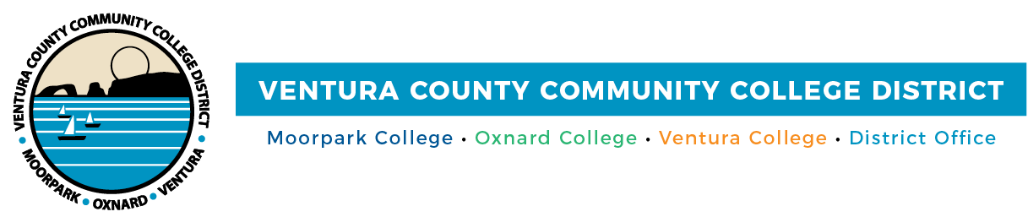

FOR IMMEDIATE RELEASE

VCCCD International Student Program
Welcomes Individuals from Six Continents
Students from around the globe receive guidance, education and cultural experiences

Camarillo, Calif. (June 10, 2022) — A majority of students in the Ventura County Community College District hail from one of the county’s 10 cities. Stepping onto the campus of Moorpark College, Oxnard College or Ventura College, however, people may meet students from Australia, Canada, South America, India, Asia, the Middle East and Africa, among other countries.

Currently, there are approximately 140 students from nearly 20 nations enrolled in the rapidly growing International Student Program (ISP) at Moorpark, Oxnard and Ventura colleges.

“ISP offers students a window on the world, providing opportunities for them to interact with people from different countries who bring their customs and life experiences into the classroom. As companies and industries become increasingly global, international and local students benefit from this broader perspective,” said Chancellor Greg Gillespie.

International students choose VCCCD campuses due to smaller class sizes, affordability when compared to a four-year college or university and the ability to earn a degree in an industry valued in their homeland. Plus they experience the “California” lifestyle and form new friendships.

“The students feel that they find a new family at our colleges,” said Cláudia Wilroy, who oversees ISP and is the VCCCD Principal Designated School Official (PDSO).

As PDSO, Wilroy helps students maintain their records in the Department of Homeland Security’s Student and Exchange Visitor Program. To assist students in achieving their educational goals, the colleges also offer support services — tutoring, academic counseling and mentorship, among others.

At Ventura County’s community colleges, international students primarily pursue associate degrees in business or computer science, said Wilroy. She is also seeing an uptick in interest in multimedia, film and television and hospitality management.

Once students graduate, transfer agreements with California State University Channel Islands or California Lutheran University (CLU) provide a pathway to a bachelor’s degree. CLU offers a $12,500 scholarship to international students transferring from a VCCCD college.

“My journey has been very rewarding and I owe a lot of credit for that to Moorpark College. Initially, I chose it on the basis of its exceptional transfer rate that it maintains among the top universities across California. … It also gave me the opportunity to pursue my higher education at a fraction of the cost as opposed to enrolling in a four-year university as a freshman,” said Areeb Rizvi, who’s from Karachi, Pakistan. Rizvi is now pursuing his bachelor’s degree in biological sciences at CLU.

“Being at Moorpark College gave me the freedom to explore issues and different subjects, allowing me to dive deep into research opportunities, network with professionals in my field and attend various inspirational conferences,” he added.

The international student program at Ventura County’s community colleges also supports Ventura County’s economic vitality. According to NAFSA, the largest association serving international educators worldwide, the program provides a financial contribution of nearly $2.6 million to the county and supports 14 jobs.

“Demand for a community college education has been increasing over the last few years in many South American and Asian countries,” said Wilroy, who represented Moorpark, Oxnard and Ventura colleges as an exhibitor at the NAFSA 2022 Annual Conference & Expo in early June. Over 6,000 international educators from all over the world attended.

“Many international educators were excited to see our VCCCD booth and to learn about the number of course offerings we have at our three colleges and the affordability of attending our schools before starting a university in the U.S.”

Learn more about the International Student Programs at VCCCD International Students or Moorpark College, Oxnard College and Ventura College.

About Ventura County Community College District
The Ventura County Community College District is a member of the 116-campus California Community College system and serves approximately 31,000 students annually. The District's three colleges — Moorpark, Oxnard and Ventura — offer programs in general education for degrees and certificates, transfer to four-year colleges and universities, career technical education, and provide opportunities to engage in co-curricular campus activities. For more information, please visit vcccd.edu.

Media Contact:
Patti Blair
Director, Public Affairs and Marketing
Ventura County Community College District
communications@vcccd.edu

