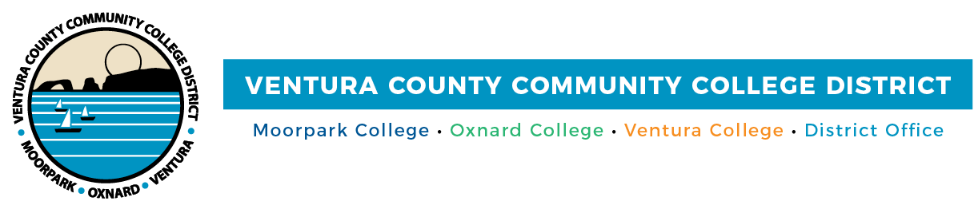

FOR IMMEDIATE RELEASE
High-Resolution Commencement Photos (by college)

VCCCD Honors Nearly 5,300 Graduates in the Class of 2022
Moorpark, Oxnard and Ventura colleges’ graduates
celebrated their first in-person commencement ceremonies in three years

(CAMARILLO, Calif.) May 27, 2022 — The excitement was palpable and the cheers enthusiastic as 5,286 students from Moorpark College, Oxnard College and Ventura College received their associate degrees and certificates at last week’s commencement ceremonies. Held at each college on May 19 or 20, these were the first in-person commencements since 2019 due to the COVID-19 pandemic.

Across the Ventura County Community College District, the class of 2022 earned 7,443 associate degrees and 4,286 certificates. Students often earn multiple degrees and certificates, which they will take with them as they transfer to four-year colleges or universities or launch their careers.

“Whether you’re graduating as a Moorpark College Raider, Oxnard College Condor or Ventura College Pirate, your dedication and hard work has helped you achieve this accomplishment. On behalf of VCCCD faculty, classified staff and administrators, thank you for your commitment to your education,” said Chancellor Greg Gillespie. “We appreciated the opportunity to support you throughout your educational journey,”

“The board of trustees congratulates the class of 2022 for their commitment to academic excellence,” said Chair Dianne McKay, whose commencement speech at each college was complemented by Trustee Gabriela Torres’s Spanish translation. “You succeeded in extraordinary times. No matter where you go from here and what your step forward is, we know you will succeed. We also hope that you will give back to this community someday.”

To further celebrate the graduates, the District continued its tradition of highlighting students in virtual yearbooks on Moorpark, Oxnard and Ventura colleges’ graduation webpages. Similar to traditional bound yearbooks, the online edition contains photos of participating graduates and their information.

After the ceremonies, the college presidents took a moment to share their pride and optimism for the graduates’ futures:

“We are proud of this year’s 2,030 graduates. They now have sought-after degrees and certificates that showcase the impact of our college in the workplace and community,” said Julius Sokenu, president of Moorpark College. “Moorpark College empowers students to explore their interests and develop their strengths so that they can pursue careers in a myriad of fields.”

“Oxnard College’s 1,070 graduates come from all walks of life and are determined to build brighter futures for themselves and their families. Their next steps onto university campuses and into rewarding careers will leave an indelible mark on Ventura County for many years to come,” said Oscar Cobian, acting president of Oxnard College.

“This was my third graduation class and my first in-person commencement as the president of Ventura College. I’m incredibly impressed by the class of 2022 and their dedication and resilience through these past couple of years,” said Kim Hoffmans. “We know this year’s class of 2,186 Pirate graduates will inspire friends and family and impact our community.”

Due to pandemic-related restrictions, graduates from the classes of 2020 and 2021 participated in drive-thru celebrations at each college’s campus and Ventura College East Campus in Santa Paula.

About Ventura County Community College District
The Ventura County Community College District is a member of the 116-campus California Community College system and serves approximately 31,000 students annually. The District's three colleges--Moorpark, Oxnard and Ventura--offer programs in general education for degrees and certificates, transfer to four-year colleges and universities, career technical education, and provide opportunities to engage in co-curricular campus activities. For more information, please visit vcccd.edu.

Media Contact:
Patti Blair
Director, Public Affairs and Marketing
Ventura County Community College District
communications@vcccd.edu

