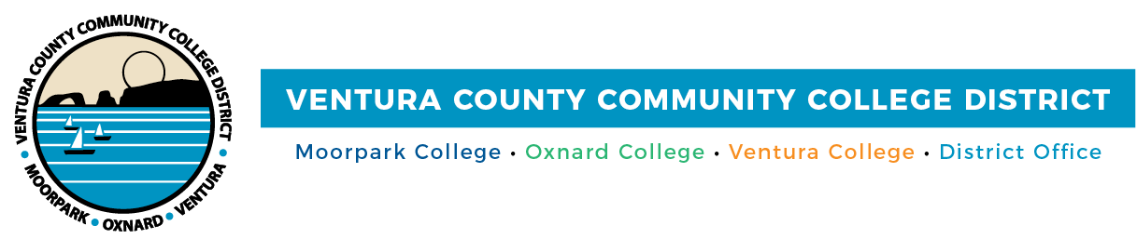

FOR IMMEDIATE RELEASE
High-Resolution photos:
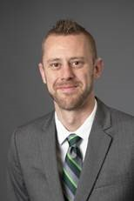 | 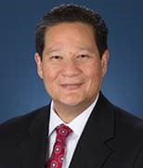 | 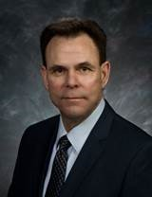
Cory Clasemann, Ph.D. | Lee Lambert, J.D. | Rick MacLennan, Ed.D.
Cory Clasemann, Ph.D.
Lee Lambert, J.D.
Rick MacLennan, Ed.D.

VCCCD Names Three Finalists for Chancellor
Candidates will participate in forums with the District community

Camarillo, Calif. (May 4, 2022)—The Ventura County Community College District (VCCCD) board of trustees announces its three final candidates for the position of chancellor. A nationwide search was conducted to replace Chancellor Greg Gillespie, who is retiring at the end of June. The finalists are, in alphabetical order: Cory Clasemann, Ph.D., vice president for student success, Ivy Tech Community College of Indiana; Lee Lambert, J.D., chancellor, Pima Community College District; Rick MacLennan, Ed.D., former president, Northern Idaho Community College.

“The Chancellor’s Search Committee conducted the search understanding just how critical this position is to the students and employees of the District, Moorpark College, Oxnard College and Ventura College. The board of trustees especially recognizes and appreciates the work of this hard-working committee. Their dedication to a thorough and extensive process led to three finalists for board consideration,” said Board Chair Dianne McKay.

The finalists will participate in Chancellor Finalist Forums from 9 a.m. to 12:15 p.m., May 10, at the Ventura County Community College District Administrative Center, 761 E. Daily Dr., Camarillo. Students, faculty, staff and administrators and community members are invited to attend the forum in person or by Zoom.

Everyone is invited to submit forum questions by 5 p.m., May 9, to
communications@vcccd.edu. Due to time constraints, not all the questions submitted may be answered; however, efforts will be made to address as many submitted topics as possible.

May 10 Forum Schedule:
Join the Forum

9 – 10 a.m. | Lee Lambert, J.D.
10:10 – 11:10 a.m. | Cory Clasemann, Ph.D.
11:15 a.m. – 12:15 p.m. | Rick MacLennan, Ed.D.

Trustees will conduct closed session interviews beginning at 3 p.m. during a special board meeting following the forums.

The finalists (in alphabetical order):

Clasemann has over 23 years of higher education experience, having served at both two-year and four-year institutions. He has a bachelor’s degree in journalism & mass communication from Creighton University, a master’s degree in organizational management from the University of Phoenix, and doctorate in higher education from Indiana University.

Lambert has served as a senior-level executive for over 20 years at three community college districts. He received a bachelor’s degree in liberal arts from The Evergreen State College in Olympia, Wash., and a Juris Doctor degree from Seattle University School of Law. Lambert was born in Seoul, South Korea, grew up on three continents and served in the U.S. Army.

MacLennan became a community college president in 2010. Prior to that, he served 12 years as vice president of Student Services at Olympic College, a three-campus comprehensive community college in Washington State. He graduated with distinction as the outstanding doctoral student from Wilmington University with a doctorate of education in educational innovation and leadership.

The finalists’ complete bios are available at VCCCD 2022 Chancellor Search.

About Ventura County Community College District
The Ventura County Community College District is a member of the 116-campus California Community College system and serves approximately 31,000 students annually. The District's three colleges--Moorpark, Oxnard and Ventura--offer programs in general education for degrees and certificates, transfer to four-year colleges and universities, career technical education, and provide opportunities to engage in co-curricular campus activities. For more information, please visit vcccd.edu.

Media Contact:
Patti Blair
Director, Public Affairs and Marketing
Ventura County Community College District
communications@vcccd.edu

