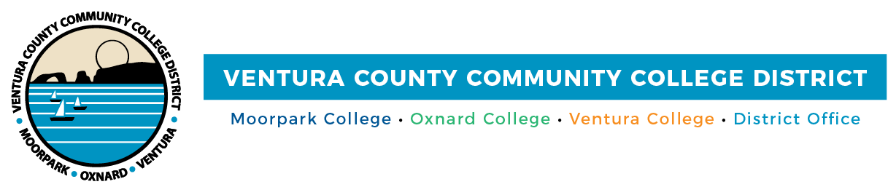

FOR IMMEDIATE RELEASE

VCCCD Celebrates DEI Month with Live and Virtual Events
Diversity in Culture Festival features renowned civil rights leader Dolores Huerta
and Chumash Land Acknowledgement on Multicultural Day

Camarillo, Calif. (March 29, 2022)—The Ventura County Community College District will join the California Community Colleges Chancellor’s Office to commemorate Diversity, Equity and Inclusion (DEI) Awareness Month. Throughout April, VCCCD and its colleges will raise awareness of DEI through free virtual and in-person events, including a webinar on April 13 with acclaimed labor and social justice activist Dolores Huerta, co-founder of the United Farm Workers union and recipient of the Presidential Medal of Freedom.

“Our students, faculty, classified staff and administrators bring diverse perspectives and experiences to the classroom and workplace,” said Board Chair Dianne McKay. “Respecting these differing views allows us to learn from one another, build trust and create a culture of belonging, acceptance and social justice across the District.”

“DEI Awareness Month provides us with another opportunity to hear the richly diverse voices on our campuses,” said Chancellor Greg Gillespie. “The activities elevate these voices and foster discussion about our ongoing commitment to creating a more inclusive and equitable community, which benefits everyone at our colleges.”

Moorpark, Oxnard and Ventura colleges will hold free events open to students, employees and the community to honor the myriad cultures represented at Ventura County’s community colleges.

Moorpark College’s annual Multicultural Day is April 12; this year’s theme is “Critical Conversations.” The theme invites and challenges the college community to participate in complex dialogue with others to advance understanding of the increasingly diverse world we inhabit. The keynote speaker will be novelist Susan Straight, who will be on campus to discuss her new novel, “Mecca,” set in the Inland Empire and high desert areas.

Other activities include a Land Acknowledgment for the Chumash people, original occupants of the land where the college resides, as well as lectures, presentations, exhibits, performances, educational booths and food from around the globe.

On April 19, Moorpark College will host a moderated conversation with novelist Angie Thomas via Zoom. The discussion will include DEI and her award-winning, acclaimed debut novel, “The Hate U Give,” and 2021’s “Concrete Rose.”

Oxnard and Ventura colleges are partnering on the 2022 Diversity in Culture Festival, April 11-14. In addition to Huerta, a sampling of the educational, engaging and empowering events includes:
- Best-selling author and poet Jason Reynolds, who has written more than a dozen books for young adults and is the current National Ambassador for Young People’s Literature.
- Afro-Fusion Dance Presentation and Instruction by Yaminah Legohn
- Motivational speaker and performer Sade Champagne discussing The Power of Self-Compassion & How to Cultivate Joy

VCCCD will also support Black Student Success Week, April 25-29. This year's theme is “A Vision for Black Student Success: Creating a New Landscape to Succeed” and will focus on new approaches to ensure Black and African American students succeed at California community colleges during the COVID-19 pandemic recovery. The week’s webinars are open to California community college administrators, staff, faculty, practitioners and students.

For more information about DEI Awareness Month events, visit VCCCD.edu/celebrate-diversity.

Ventura County Community College District
The Ventura County Community College District is a member of the 116-campus California Community College system and serves approximately 31,000 students annually. The District's three colleges—Moorpark, Oxnard and Ventura—offer programs in general education for degrees and certificates, transfer to four-year colleges and universities, career technical education, and provide opportunities to engage in co-curricular campus activities. For more information, please visit vcccd.edu.

Media Contact:
Patti Blair
Director, Public Affairs and Marketing
Ventura County Community College District
communications@vcccd.edu

