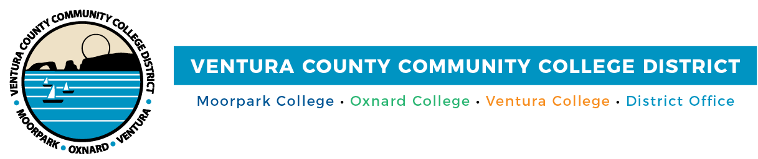

FOR IMMEDIATE RELEASE

VCCCD Colleges Host Cash 4 College Workshops
Financial Aid Staff Will Assist Students in Accessing Funds for College

(CAMARILLO, Calif.) January 31, 2022–Moorpark College, Oxnard College, Ventura College and Ventura College East Campus are holding free Cash 4 College workshops to help students apply for funds to use for college. Workshops are scheduled for Feb. 12 and Feb. 26 and will be by Zoom. Students can drop in anytime during the workshops.

Bilingual financial aid staff will assist students in completing applications for the 2022-2023 school-year FAFSA (Free Application for Federal Student Aid) or the California Dream Act Application (CADAA). The workshops are open to the community; people may attend a workshop on either date. Advance registration is preferred.

For more information, visit vcccd.edu/cash4college.

Moorpark College
Feb. 12
Feb. 26
9 a.m. – noon
Zoom link: http://bit.ly/C4CFeb22
Join from PC, Mac, Linux, iOS or Android

For info: Moorpark College Financial Aid Office
Phone: (805) 378-1462
Email: mcfa@vcccd.edu

Oxnard College
Feb. 12
Feb. 26
9 a.m. – noon
Zoom link: http://bit.ly/C4CFeb22
Join from PC, Mac, Linux, iOS or Android

For info: Oxnard College Financial Aid Office
Phone: (805) 678-5828
Email: ocfinaid@vcccd.edu

Ventura College and Ventura College East Campus
Feb. 12
Feb. 26
9 a.m. – noon
Zoom link: http://bit.ly/C4CFeb22
Join from PC, Mac, Linux, iOS or Android

For info: Ventura College and Ventura College East Campus Financial Aid Office
Phone: (805) 289-6369
Email: vcfinancialaid@vcccd.edu

About Ventura County Community College District
The Ventura County Community College District is a member of the 116-campus California Community College system and serves approximately 31,000 students annually. The District's three colleges—Moorpark, Oxnard and Ventura—offer programs in general education for degrees and certificates, transfer to four-year colleges and universities, career technical education and provide opportunities to engage in co-curricular campus activities. For more information, visit www.vcccd.edu.

Media Contact:
Patti Blair
Director, Public Affairs and Marketing
Ventura County Community College District
communications@vcccd.edu

