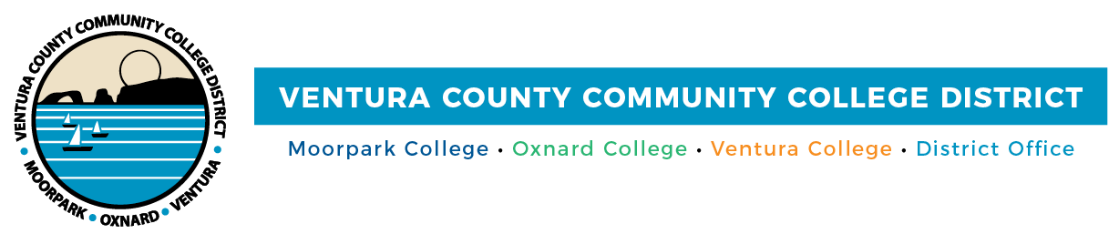

FOR IMMEDIATE RELEASE

Ventura County’s Community Colleges Respond to COVID-19 Surge
Campuses will start Spring 2022 semester primarily online

Camarillo, Calif. (January 5, 2022)—To protect the health of students and employees within the Ventura County Community College District and to help mitigate the surge in the county’s COVID-19 cases, Ventura County’s community colleges will start the Spring 2022 semester primarily online beginning Jan. 10. Spring classes at Moorpark, Oxnard and Ventura colleges and Ventura College East Campus will be mainly remote for a limited time with exceptions for classes requiring in-person instruction. Scheduled in-person class sessions will be reinstated following a reduction in COVID-19 infections and hospitalizations.

“The health and safety of our students and employees has been paramount in operations throughout the COVID-19 pandemic. We made the current decision to help reduce transmission and support ongoing public health efforts. We know we must be flexible in our planning as we approach the start of the Spring semester. Remote instruction will contribute to reducing employee and student absences as we help students attain their educational goals,” said Chancellor Greg Gillespie.

“We need to make sure that our campuses are safe, which is why the board of trustees voted unanimously to mandate the vaccine for all students, faculty and staff on our campuses. Online options are available for students who choose not to be vaccinated,” added Board Chair Dianne B. McKay.

Only vaccinated employees and students, and those with an approved exemption, can be on-site. All health and safety protocols currently in place will continue, including daily screening, wearing face masks and twice-weekly testing for people with medical or religious exemptions.

The District's action related to remote learning for the Spring semester will be continually monitored with input from the Ventura County Public Health Department and in accordance with applicable laws, regulations and guidelines.

The Centers for Disease Control and Prevention (CDC) guidelines state the best protection against COVID-19 is to be vaccinated and get a booster shot. Ventura County vaccination information is available at Ventura County Recovers. Vaccination appointments can be scheduled online at MyTurn.

Ventura County Community College District
The Ventura County Community College District is a member of the 116-campus California Community College system and serves approximately 31,000 students annually. The District's three colleges--Moorpark, Oxnard and Ventura--offer programs in general education for degrees and certificates, transfer to four-year colleges and universities, career technical education, and provide opportunities to engage in co-curricular campus activities. For more information, please visit vcccd.edu.

Media Contact:
Patti Blair
Director, Public Affairs and Marketing
Ventura County Community College District
communications@vcccd.edu

