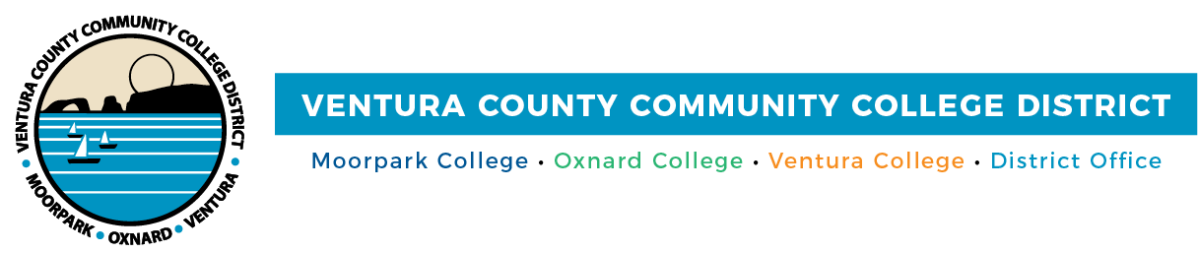

FOR IMMEDIATE RELEASE

Ventura County Community College District Elects New Board Officers
Trustees approve $1.5 million to expand class offerings at Oxnard College

Camarillo, Calif. (December 21, 2021)—The Ventura County Community College District Board of Trustees elected longtime Trustee Dianne B. McKay as board chair during the District’s Annual Organizational Meeting on Dec. 14. The board elected Trustee Stan Mantooth as vice chair and Chancellor Greg Gillespie as secretary.

McKay and Mantooth will continue to work with Trustees Josh Chancer, Bernardo M. Perez and Gabriela Torres in conducting board business and reviewing and adopting policies that regulate activities in the District and its colleges in Moorpark, Oxnard and Ventura. Student Trustee Bryan Rodriguez, a political science major at Ventura College, will continue to advocate for the District’s approximately 31,000 students. The board of trustees is elected in even-numbered years to four-year terms by Ventura County voters. The student trustee is elected annually through a district-wide student election.

“Our board is diligently addressing several critical priorities this year, including continued support for our students and staff to return safely to our campuses, rebuilding enrollment and navigating the selection process of a new chancellor,” said McKay. “We will continue to collaborate as a board to lead with policy decisions that provide our students with transformative learning opportunities so they can achieve their highest potential.”

McKay, who represents Area 2, was first elected to the VCCCD board in 2010; she was re-elected in 2014 and 2018 and has held leadership positions throughout her tenure. McKay owns and serves as president of the county’s oldest and largest marketing firm, Mustang Marketing. She represents statewide community college trustees on the Community College League of California Advisory Committee on Education Services, which plans training and events for new and continuing trustees throughout the state. Her areas of interest include economic development and diversity, equity and inclusion. She also strongly advocates for dual enrollment, which enables high school students to earn both high school and college credit at the same time.

Mantooth, who was elected in 2020, represents Area 3. He retired after more than four decades in K-12 school districts and the Ventura County Office of Education. In 2010, 2014 and 2018, he was elected to successive four-year terms as County Superintendent of Schools. Mantooth has served on various local and statewide organizations, including the California County Superintendents Educational Services Association, First 5 Ventura County and the Ventura County School Boards Association.

“I am excited to continue the work the board has done to advance student success,” said Mantooth. “My ties with local educators will bolster our partnerships with schools across the county, allowing them to see the benefits our colleges provide to those seeking a degree or certificate.”

After electing new board leadership, trustees unanimously approved investing $1.5 million in reserves toward expanding class offerings at Oxnard College. Under the initiative, the college will expand its English as a Second Language program to include courses at multiple locations throughout the community and reestablish its Program for Accelerated College Education (PACE) for working adults, which will enable students to complete an associate degree in about two years.

Oxnard College’s PACE will offer online and fast-track certificates and degrees in business, paralegal studies and elementary teacher education. The initiative will begin in fall 2022 and will be implemented over three years. Moorpark College’s PACE program offers degrees in business administration, early childhood education, computer science, general studies and psychology. Ventura College also plans to implement a PACE program. In addition to the degrees and certificate programs offered at the main campus in Ventura, Ventura College East Campus, serving the Santa Clara River Valley, offers associate degrees in arts and humanities, behavioral and social sciences and veterinary science.

“Our board remains committed to increasing equity and access to all our students to ensure that they receive a quality education that leads to meaningful employment and a living wage,” added Gillespie.

The next regular board of trustees meeting will be Jan. 18 via Zoom and in-person. Detailed information regarding board meetings can be found at vcccd.edu/board-of-trustees.

Ventura County Community College District
The Ventura County Community College District is a member of the 116-campus California Community College system and serves approximately 31,000 students annually. The District's three colleges--Moorpark, Oxnard and Ventura--offer programs in general education for degrees and certificates, transfer to four-year colleges and universities, career technical education, and provide opportunities to engage in co-curricular campus activities. For more information, please visit vcccd.edu.

Media Contact:
Patti Blair
Director, Public Affairs and Marketing
Ventura County Community College District
communications@vcccd.edu

