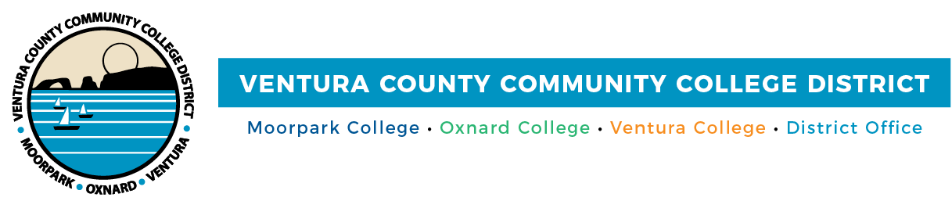

FOR IMMEDIATE RELEASE

New Program Mapper Steers Ventura County Community College
Students to a Career
Students Reach Their Certificate or Degree More Efficiently and Faster

Camarillo, Calif. (November 1, 2021)—Choosing a major that leads to a rewarding career can be overwhelming for students. But it doesn’t have to be that way. The Ventura County Community College District just introduced Program Mapper, an innovative, detailed visual course guide that allows students to explore future work possibilities, while simultaneously showing them the required courses and earning potential for that career.

Developed through a collaboration between California Community Colleges and software developer Concentric Sky, Program Mapper helps students at Moorpark, Oxnard and Ventura colleges visualize their degree or certificate options on a semester-by-semester basis. Organized around areas of interest and grouped by career and academic majors, the new tool guides students through the District’s more than 200 program offerings, while helping them chart a path to completing a degree or certificate.

“I am very excited that Program Mapper will be available to students,” said Alyna Zarate, a Ventura College student who participated in a student focus group. “I think Program Mapper will be beneficial and helpful to students because it creates a clear path that includes career data and classes needed in relation to a major and helps students explore different program options they may have.”

All the student focus group participants were enthusiastic about the new program. They said it was a “cool” college planning tool that will help them map out their education so they can complete their degree and graduate in two years.

This is noteworthy because only 48% of students enrolled in a community college complete their degree or certificate, according to the California Community Colleges Chancellor’s Office. When students obtain their associate degree, they typically take 87 units, which is 27 units more than the minimum required.

As students visit Program Mapper on the websites of Moorpark College, Oxnard College and Ventura College, they find user-friendly learning and career pathways associated with their interests. These span the arts, business and technology, communications and languages, education, health and wellness, the social sciences and STEM. Next, they can find information about the skills they will acquire from specific programs of study, industries where they can apply these skills and required coursework. Salary range and career growth information are also included.

“Program Mapper is a helpful tool that enables students to explore a wide range of fields to study. In the process, they may find a career path they wouldn’t have thought of. This is exciting to me, as it helps students reach their goals more quickly and without the guesswork,” said Board Chair Joshua Chancer.

“Program Mapper’s easy-to-use interactivity allows students to feel more connected to the program selection process since they can see how their interests align with specific areas of study and potential careers and the classes required,” said Chancellor Greg Gillespie. “I wish Program Mapper was around when I was choosing a major.”

Program Mapper also gives Ventura County community college students information about baccalaureate degree programs in the California State University system for associate degrees for transfer and proficiency awards available through the colleges.

The District’s colleges advise that students use Program Mapper as a tool in conjunction with working with an academic counselor to ensure they meet all academic requirements for program completion.

Program Mapper is the result of Guided Pathways, California Community Colleges’ highly structured approach to student success that offers all students a set of clear course patterns to promote better enrollment decisions and prepare students for future success.

About Ventura County Community College District
The Ventura County Community College District is a member of the 116-campus California Community College system and serves approximately 31,000 students annually. The District's three colleges—Moorpark, Oxnard and Ventura—offer programs in general education for degrees and certificates, transfer to four-year colleges and universities, career technical education, and provide opportunities to engage in co-curricular campus activities. For more information, please visit vcccd.edu.

Media Contact:
Patti Blair
Director, Public Affairs and Marketing
Ventura County Community College District
communications@vcccd.edu

