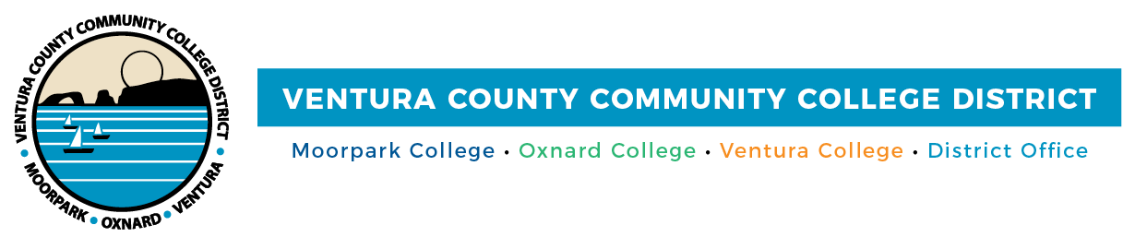

FOR IMMEDIATE RELEASE

VCCCD Highlights Retiree Health Benefits and
Expanded Learning Opportunities Across Ventura County
Measures yield significant cost savings and programs that meet community needs

Camarillo, Calif. (November 4, 2021)—Ventura County Community College District will preserve retirees’ comprehensive health benefits, while saving taxpayers $53 million, and Spanish speakers can learn English in Piru, thanks to two of the many actions recently taken by the board of trustees. The board also passed a measure to receive contract funding for workforce development.

The taxpayer savings was noted in the 2021 Actuarial Study of Retiree Health Liabilities from Total Compensation Systems, Inc., which illustrates how the recent transition of purchasing retirees’ medical benefits through California Public Employees’ Retirement System (CalPERS) saves taxpayer dollars today and into the future through a substantial reduction of the District’s Net Other Post-Employment Benefits (OPEB) liability.

“This is a win for everyone. The District’s retirees keep their well-earned health benefits, while the District saved taxpayer funds that we can use toward our mission of providing students quality educational opportunities,” said Vice Chair Dianne B. McKay at the October board meeting. “Having been involved in negotiations related to this matter for the past several years, my fellow board members, Chancellor Gillespie, the vice chancellors and I are satisfied with the outcome.”

To manage costs for health benefits, the District has also placed funds in a qualifying irrevocable trust. The funds in this trust will help pay for the District’s retirees’ health plans for eligible employees.

Trustees also took action to approve a memorandum of understanding with the Ventura County Parks and Recreation Division to lease a multipurpose room at the Piru Community Center. The space will enable Ventura College to offer students and community members English as a Second Language (ESL) classes as a joint venture with the parks and recreation division.

In another Board approved action, the Districtwide Division of Economic and Workforce Development will receive up to $65,000 in funds from the County of Ventura to offer customized safety training to the county’s Children and Family Services employees and current and potential caregivers. Courses include training in first aid, CPR and automated external defibrillation (AED) to treat sudden cardiac arrest.

Funding for the Division of Economic and Workforce Development serves the District and its campuses’ missions to improve student success and support workforce development in Ventura County. Funds will go toward operating expenses, including licenses, training and supplies.

“These partnerships will give more students and community members firsthand learning experiences so they can continue their education and prosper or use potentially lifesaving techniques on their loved ones and fellow citizens,” said Chancellor Greg Gillespie. “The partnerships also allow us to establish strategic alliances throughout Ventura County, which address our community’s business needs.”

About Ventura County Community College District
The Ventura County Community College District is a member of the 116-campus California Community College system and serves approximately 31,000 students annually. The District's three colleges—Moorpark, Oxnard and Ventura—offer programs in general education for degrees and certificates, transfer to four-year colleges and universities, career technical education, and provide opportunities to engage in co-curricular campus activities. For more information, please visit vcccd.edu.

Media Contact:
Patti Blair
Director, Public Affairs and Marketing
Ventura County Community College District
communications@vcccd.edu

