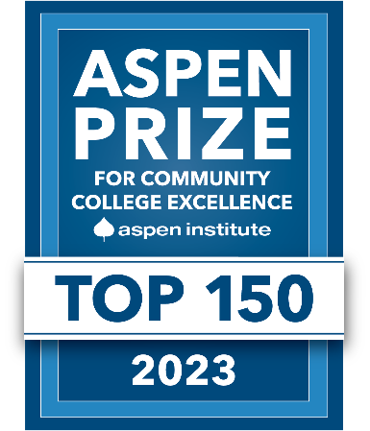

FOR IMMEDIATE RELEASE

Ventura County’s Community Colleges Named Among 150 U.S. Community Colleges Eligible for 2023 Aspen Prize
Moorpark, Oxnard and Ventura Colleges Vie for Coveted Award
That Celebrates Excellence and Equity in Higher Education

Camarillo, Calif. (November 2, 2021)—Ventura County’s community colleges are among 150 institutions nationwide eligible to compete for the $1 million Aspen Prize for Community College Excellence. Moorpark, Oxnard and Ventura colleges are now eligible for the 2023 prize, known as the nation's signature recognition of high achievement and performance among America's community colleges. It recognizes colleges with robust student outcomes in equity, teaching and learning, certificate and degree completion, transfer rates and bachelor’s degree attainment and workforce success.

Only 15% of the approximately 1,000 community colleges the Aspen Institute evaluates across the U.S. are selected to contend for the esteemed honor. This is the first time that all three Ventura County Community College District colleges have been eligible for the Aspen Prize at the same time. Ventura College was previously eligible in 2017, 2019 and 2021; and Moorpark College in 2019.

Since 2010, Aspen has chosen to focus intensively on community colleges because they are—as First Lady Dr. Jill Biden stated at the 2021 Aspen Prize ceremony—“our most powerful engine of prosperity.”

The 150 eligible colleges have been invited to submit data and narratives as next steps in an intensive data and practice review process. The top 10 finalists for the 2023 Aspen Prize will be announced in spring/summer 2022. Following the announcement, the Aspen Institute will conduct two-day site visits to each finalist institution to gather additional data on employment and earnings outcomes and practices in learning assessment.

A jury of notable leaders will select a winner, finalists with distinction and institutions that have significantly improved their practices known as “Rising Stars” in late spring 2023.

Following the announcement of being named eligible for the prize, the VCCCD board and college presidents expressed their appreciation of the honor:

“The fact that each of our colleges is eligible for this prize serves as a testament to the District’s commitment to equity and high-quality education that yields professional and personal success for our diverse students,” said VCCCD Board Chair Joshua Chancer.

“It is truly an honor for Moorpark College to be recognized for a second time, especially when we are getting back on track after a global pandemic,” said Dr. Julius Sokenu, president of Moorpark College. “We recognize the excellence of our instructors, staff and administrators who continue to model even while meeting our greatest challenges. The work we have done in exploring new technologies and modalities—as well as our continued dedication to diversity, equity and inclusion—are just a few of the elements that make Moorpark College a very special place.”

“We at Oxnard College are grateful to the Aspen Institute for recognizing the impactful work we do to transform students’ lives,” said Luis Sanchez, president of Oxnard College. “For nearly a half-century, Oxnard College has faithfully served our community’s immigrant, military and working-class families. Indeed, our state-of-the-art facilities, integrated student services and award-winning academic and career programs have lifted thousands of Ventura County families into the middle class and strengthened our local economy.”

“Ventura College is honored to be recognized multiple times. It reflects Ventura College's educational opportunities and academic success as an accredited two-year institution of higher education,” said Dr. Kim Hoffmans, president of Ventura College. “This distinction illustrates the dedication of our faculty, classified professionals and administrators and their commitment to the success of all Ventura College students.”

For the list of the top 150 eligible institutions and to read more on the selection process, visit https://highered.aspeninstitute.org/aspen-prize/. The Aspen Prize is made possible by generous support from Ascendium and the Joyce Foundation.

About the Aspen Institute
The Aspen Institute College Excellence Program aims to advance higher education practices and leadership that significantly improve student learning, completion, and employment after college-especially for the growing population of students of color and low-income students on American campuses. For more information, visit https://highered.aspeninstitute.org.

The Aspen Institute is a global nonprofit organization committed to realizing a free, just, and equitable society. Founded in 1949, the Institute drives change through dialogue, leadership, and action to help solve the most important challenges facing the United States and the world. Headquartered in Washington, DC, the Institute has a campus in Aspen, Colo., and an international network of partners. For more information, visit www.aspeninstitute.org.

Ventura County Community College District
The Ventura County Community College District is a member of the 116-campus California Community College system and serves approximately 31,000 students annually. The District's three colleges—Moorpark, Oxnard and Ventura—offer programs in general education for degrees and certificates, transfer to four-year colleges and universities, career technical education, and provide opportunities to engage in co-curricular campus activities. For more information, please visit vcccd.edu.

Media Contact:
Patti Blair
Director, Public Affairs and Marketing
Ventura County Community College District
communications@vcccd.edu

