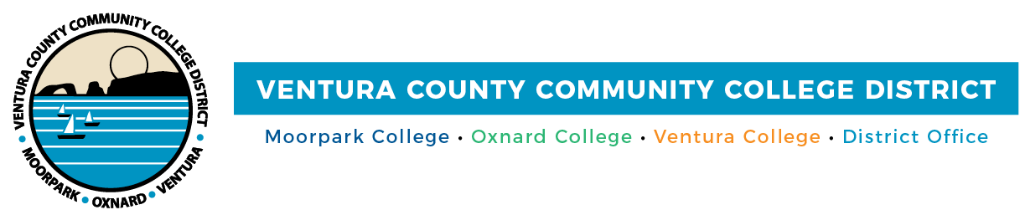

FOR IMMEDIATE RELEASE

Department of Education Awards VCCCD Colleges
Grants of Nearly $10 Million
Grants Will Support Hispanic-Serving Institutions STEM Program Projects

Camarillo, Calif. (October 22, 2021)—Two Ventura County Community College District colleges have received multi-million-dollar federal grants to support STEM programs targeting underrepresented students interested in pursuing science, technology, engineering and math-related fields. A grant for Oxnard College totals $4,901,245, and the grant for Ventura College is $5 million. Both grants are for the period of Oct. 1, 2021, to Sept. 30, 2026.

“For the third consecutive time, the U.S. Department of Education has recognized Oxnard College’s leading work in STEM education through the Hispanic-Serving Institution STEM grant,” shared Luis Sanchez, president of Oxnard College. “This grant’s renewal will infuse additional resources and staffing into our academic programs, expanding career pathways in STEM for countless Ventura County students and their families. We relish the opportunity to continue this life-changing work for our community.”

Oxnard College’s grant supports the college’s Guided Pathways to STEM Careers project, which is grounded in published research and modeled after programs that produce intended outcomes in STEM. Areas the grant will fund include internships and co-curricular experiences, which connect academic courses to real-world issues and enhance student learning. It will also support peer mentoring activities that lead to increased student retention and faculty-led active learning environments to improve engagement and learning.

In addition, Oxnard College’s grant will fund case managers who will proactively advise students on their coursework and career goals, allowing them to complete their associate degrees and transfer to baccalaureate STEM programs. It will also develop formal written transfer agreements with four-year colleges and universities for Oxnard College students.

Ventura College will use its grant for its Servingness: Aspiration, Identity, and Learning (S:AIL) in STEM project for students attending its main campus in Ventura and Ventura College East Campus in Santa Paula. This project aims to increase access and participation in STEM degrees/careers, provide more equitable degree and career outcomes and increase transfer rates to STEM programs in the California State University and University of California systems.

“The college degree pipeline for Hispanic students most often starts at the community college level, but there are many barriers to educational attainment and transfer, particularly in STEM. This grant will help close the achievement gap for Ventura College students from underrepresented communities by providing them with resources to ensure their success in coursework at our college and later at a four-year college or university,” said Dr. Kim Hoffmans, president of Ventura College.

Through the grant, Ventura College students will receive enhanced tutoring, counseling and service programs created to improve their academic success. This includes innovative and customized instruction in gateway English and math courses to retain students and accelerate program completion and transfer rates to four-year higher education institutions. The grant will also address the gaps in the community college to university pipeline by fostering flexible and affordable paths to obtaining knowledge and skills. This will occur through students’ participation in experiential and work-based learning.

“Equity is a cornerstone of the District, and these grants offer valuable assistance for our Hispanic students and others facing economic challenges at Oxnard and Ventura colleges,” said Chancellor Greg Gillespie. “The education the students receive at our colleges, along with the support services, will them on the path to lifelong learning and achievement in the fields in science, technology, engineering and math.”

Oxnard and Ventura colleges are Hispanic-Serving Institutions, meaning they meet certain eligibility requirements as institutions of higher education, and the student population has at least 25% Hispanic students at the end of an award year immediately preceding the date of a grant application. Oxnard College counts 76% of its students as Hispanic, and Ventura College, 61%.

Ventura County Community College District
The Ventura County Community College District is a member of the 116-campus California Community College system and serves approximately 31,000 students annually. The District's three colleges--Moorpark, Oxnard and Ventura--offer programs in general education for degrees and certificates, transfer to four-year colleges and universities, career technical education, and provide opportunities to engage in co-curricular campus activities. For more information, please visit vcccd.edu.

Media Contact:
Patti Blair
Director, Public Affairs and Marketing
Ventura County Community College District
communications@vcccd.edu

