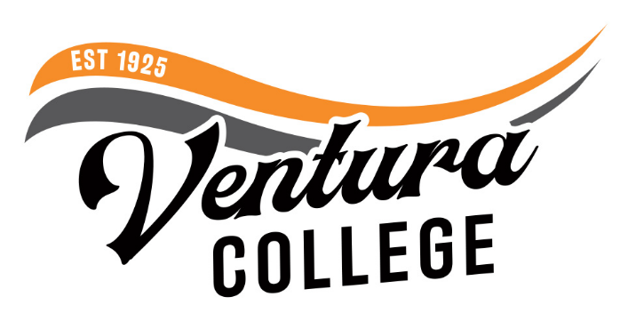
4667 Telegraph Road
Ventura, CA 93003
805.289.6000
venturacollege.edu

FOR IMMEDIATE RELEASE

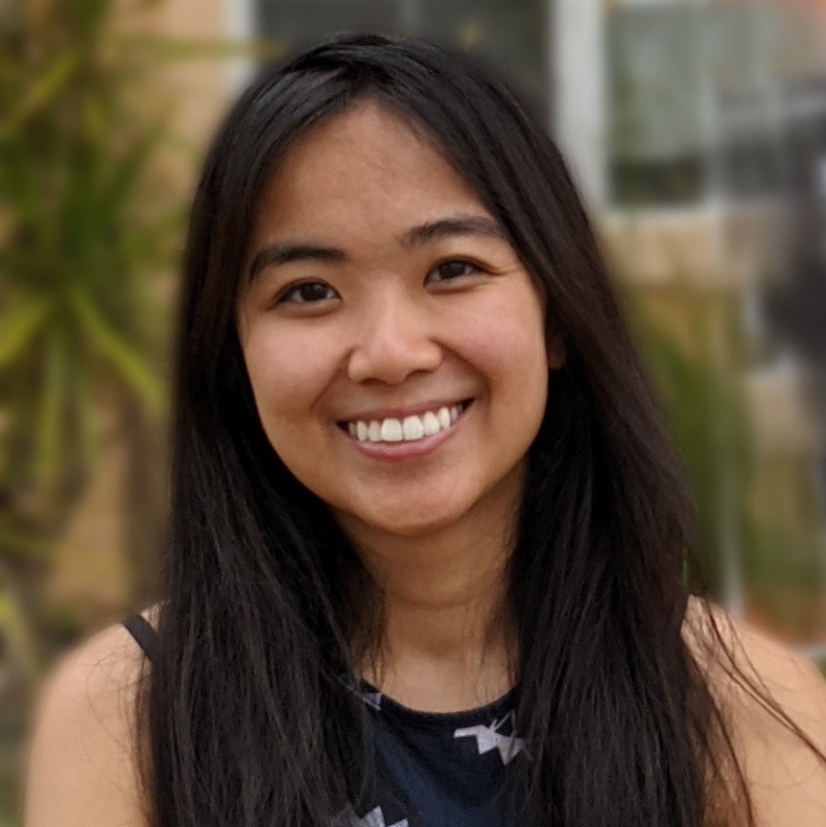
Angela Duran, Ventura College Student

Ventura College Student Angela Duran Obtains Statewide STEM Scholarship
College’s MESA Program Supports Duran in Her Educational Goals

(VENTURA, Calif.) October 20, 2021—Ventura College computer science major Angela Duran is one of 11 students statewide to receive a $1,000 scholarship from the Chief Information Systems Officers Association (CISOA), a nonprofit organization supporting technology leadership in the California Community College System. Duran was one of the more than 150 applicants from 31 community college districts who applied for the 2021 CISOA Student Scholarship.

Duran has been supported in her educational goals through the college’s Mathematics, Engineering and Science Achievement (MESA) program, whose mission is to help underserved and underrepresented students be successful in STEM studies and careers.

“Having MESA on campus and the support of CISOA go a long way in helping students like Angela gain access to STEM careers,” said Ventura College President Kim Hoffmans. “Through the work of these organizations, along with the encouragement of the college’s professors, students are inspired to reach higher in their academic goals.”

“The MESA program at Ventura College is filled with other ambitious students and caring staff. April Montes, MESA director, and Angelica Ramos, student services assistant, have been like second parents to me, helping me through the ups and downs of my academic journey,” said Duran. “The MESA program has helped me persevere through hardships and take risks that will springboard me to success. Without MESA’s motivational push, I likely would not have applied to as many scholarships as I have so far.”

Learning she was a CISOA scholarship recipient, Duran’s first reaction was pride that her efforts had been recognized. “Affording college has been my most difficult obstacle to tackle. With less financial burden, my stress has been relieved, allowing me to better focus my attention on my studies,” said Duran, who is also a computer science and math tutor at Ventura College.

“As a MESA member, Angela has demonstrated passion and determination to pursue her degree in computer science. She is bright, energetic, compassionate and genuinely well-rounded. Angela has taken advantage of many opportunities at Ventura College to grow academically and professionally by applying to internships and attending community events and workshops. She is a go-getter!” said Montes.

For the CISOA application, students were required to be currently enrolled in college at least part-time (6 units per term) with a 3.0 GPA or higher and have declared a major in an Information Technology-related field of study (computer networking, management information system (MIS), computer science, cyber security and electronics). Each applicant provided a personal statement outlining their educational goals and plan for using the scholarship funds.

For more information about MESA at Ventura College, contact Montes at (805) 289-6538 or amontes@vcccd.edu or visit About MESA | Ventura College.

About Ventura College
Ventura College, the first institution of higher education in Ventura County, has provided quality education to the community since 1925. A designated Hispanic-Serving Institution, the college enrolls over 13,000 students each semester at two campuses. VC offers over 70 disciplines of study in STEM fields, business, the arts, education, social/behavioral sciences, liberal arts, and the health sciences. Named one of the nation’s top 150 community colleges by the Aspen Institute College Excellence Program, it is the largest provider of workforce participants in the county in manufacturing, automotive technology, and nursing. To learn more, visit VenturaCollege.edu.

Media Contact:
Su-Lin Rubalcava
Director of Marketing and Outreach, Ventura College
(805) 289-6410
srubalcava@vcccd.edu

