FOR IMMEDIATE RELEASE
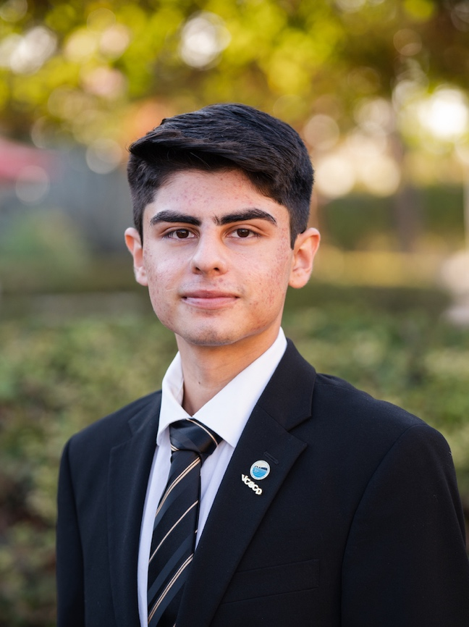
Bryan Rodriguez, Student Trustee

New Student Trustee Joins VCCCD Board of Trustees
Ventura College Student Bryan Rodriguez Aims to Boost DEI Initiatives
and Address Impact of Student Financial Insecurity

Camarillo, Calif. (October 13, 2021)—The Ventura County Community College District Board of Trustees installed Bryan Rodriguez as Student Trustee for the 2021-22 academic year at its Oct. 12 meeting. A Ventura College student, Rodriguez was selected through a districtwide special student election in Sept. He joins the District’s elected board consisting of Chair Joshua Chancer, Vice Chair Dianne B. McKay and Trustees Stan Mantooth, Bernardo M. Perez and Gabriela Torres.

As the Student Trustee, Rodriguez will represent and advocate for the District’s approximately 31,000 students at Moorpark, Oxnard and Ventura colleges at monthly Board of Trustees’ meetings and other constituent meetings across the District. He will also participate in professional development conferences and assist the board in advocating for the District, both statewide and nationally.

“I am thrilled to once again have a student trustee serve with our full board, one who understands the many academic and personal challenges college students face,” said Chair Chancer. “Through sharing his perspective as a first-generation college student, he can help inform the conversations around enhancing the student experience at the District’s colleges.”

“Having attended previous board meetings and establishing relationships with members, Bryan is knowledgeable about the responsibility of being a student trustee. The board and I look forward to his input and collaborating with him,” added Chancellor Greg Gillespie.

A political science major, Rodriguez serves as president of M.E.Ch.A. (Movimiento Estudiantil Chicanx De Aztlán). He is also an active member of the Political Science Club at Ventura College, which focuses on the interests of students aspiring to enter politics.

Rodriguez gained hands-on experience in his major by working as an intern at the office of Assemblymember Jacqui Irwin. This year, he interned with the California Latinx Capitol Foundation Association and attended conferences and training sessions hosted by the Community College League of California and the Student Senate for California Community Colleges.

Some of his policy positions include increasing diversity, equity and inclusion initiatives that benefit students on campus and in their communities and addressing the impact of financial insecurity within the student population. In addition, he advocates for a more flexible curriculum and creating a culture of community and student engagement at Moorpark, Oxnard and Ventura colleges and Ventura College East Campus.

“I believe all students should have input on the policies that affect their lives and education, and, subsequently, their futures,” said Rodriguez. “I am thrilled and honored to represent the students in the District and look forward to working with the VCCCD board of trustees to help ensure the academic—and personal—success of the student population.”

About Ventura County Community College District
The Ventura County Community College District is a member of the 116-campus California Community College system and serves approximately 31,000 students annually. The District's three colleges—Moorpark, Oxnard and Ventura—offer programs in general education for degrees and certificates, transfer to four-year colleges and universities, career technical education, and provide opportunities to engage in co-curricular campus activities. For more information, please visit vcccd.edu.

Media Contact:
Patti Blair
Director, Public Affairs and Marketing
Ventura County Community College District
communications@vcccd.edu

