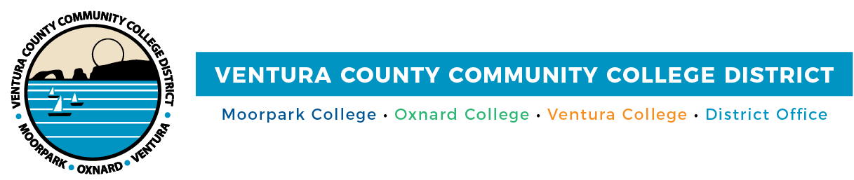

FOR IMMEDIATE RELEASE

Action Week Focuses on Lasting Change for Undocumented College Students
VCCCD Joins California Community Colleges in
Sustained Commitment to the State’s Undocumented Students

Camarillo, Calif. (October 11, 2021)—The Ventura County Community College District unites with California Community Colleges and its statewide partners for the fifth annual Undocumented Student Action Week, Oct. 18-22. This year’s theme, “Change in Action,” serves as a catalyst for California Community Colleges, the District and its colleges--Moorpark, Oxnard and Ventura--to continue to empower undocumented students in their goal of attaining a college education.
Across the state, several educational organizations and nonprofits lead the efforts for Undocumented Student Action Week. They include the California Community Colleges Chancellor’s Office, the Community College League of California, the Foundation for California Community Colleges, Immigrants Rising, California Student Aid Commission, the California Undocumented Higher Education Coalition, Academic Senate for California Community Colleges and the Student Senate for California Community Colleges.
California Community Colleges’ dedication to serving students from all countries– regardless of their immigration status – during Undocumented Student Action Week has resulted in funding for Dream Resource Centers, including Oxnard College’s Dream Resource Center, the creation of an Immigration Legal Services Project, the preservation of Deferred Action for Childhood Arrivals (DACA) and the extension of AB 540 eligibility. The latter allows undocumented students who meet certain criteria to pay in-state tuition at California’s public universities and community colleges.
“The District remains committed to advocating for undocumented students in their pursuit of higher education and a better life,” said Chair Joshua Chancer. “We know they and their families experience unique challenges, and we are here to ease those burdens year-round through on-campus programs at Moorpark, Oxnard and Ventura colleges.”
California Community Colleges is the nation’s largest post-secondary education system that serves the largest number of undocumented students within the state, including up to 70,000 enrolled in California’s community colleges protected by DACA. Despite this policy, undocumented students still face numerous challenges such as persistent anxiety over deportation and access to federal financial aid and meaningful work opportunities. Many also balance family and work obligations along with their academic endeavors.
“During Undocumented Student Action Week and throughout the year, the District and its colleges unequivocally lend their support to our undocumented students who bring their cultural wealth and experiences to our campuses,” said Chancellor Greg Gillespie. “Moorpark, Oxnard and Ventura colleges provide these students and their families access to resources that enable them to succeed, including pro-bono legal services and financial assistance and fellowships from the state.”
Moorpark, Oxnard and Ventura colleges and Ventura College East Campus, will offer a variety of resources during Undocumented Student Action Week. Events include webinars on undocumented students’ rights and the resources available to them, financial aid workshops and a virtual town hall featuring college leadership. A complete list of events, which are free and open to students, their families, faculty, staff and community allies, is available at https://www.vcccd.edu/students/undocually.
About Ventura County Community College District
The Ventura County Community College District is a member of the 116-campus California Community College system and serves approximately 31,000 students annually. The District's three colleges--Moorpark, Oxnard and Ventura--offer programs in general education for degrees and certificates, transfer to four-year colleges and universities, career technical education and provide opportunities to engage in co-curricular campus activities. For more information, visit vcccd.edu.
###
Media Contact:
Patti Blair
Director, Public Affairs and Marketing
Ventura County Community College District
communications@vcccd.edu

