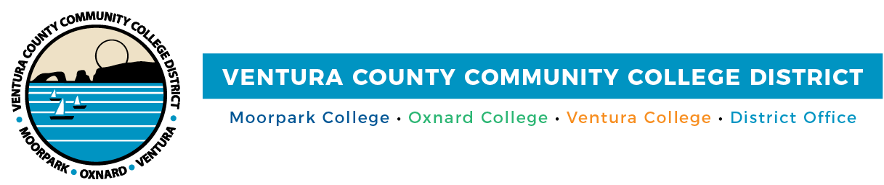

FOR IMMEDIATE RELEASE

Cash 4 College
Workshops Help Students Access Funds for College

(CAMARILLO, Calif.) September 28, 2021– To help students overcome the challenge of paying for college, Moorpark College, Oxnard College, Ventura College and Ventura College East Campus are holding free Cash 4 College workshops. Workshops will be Oct. 9 and Oct. 23, and will be in-person or by Zoom, depending on the campus (details below). Students can drop in anytime during the workshops and attend any campus workshop.

Bilingual financial aid staff will assist students in completing applications for the 2022-2023 school-year FAFSA (Free Application for Federal Student Aid) or the California Dream Act Application (CADAA). The workshops are free and open to the community; people may attend a workshop on either date and at any campus. Advance registration is preferred.

For more information, visit vcccd.edu/cash4college

Moorpark College
Oct. 9
9 a.m. – 11 a.m.
Zoom link: bit.ly/MC-cash1
Join from PC, Mac, Linux, iOS or Android

Oct. 23
9 a.m. – 11 a.m.
Zoom link: bit.ly/MC-cash2
Join from PC, Mac, Linux, iOS or Android

For info: Moorpark College Financial Aid Office
Phone: (805) 378-1462
Email: mcfa@vcccd.edu

Oxnard College
Oct. 9
Oct. 23
9 a.m. – noon
Zoom link: bit.ly/OC-cash
Join from PC, Mac, Linux, iOS or Android

For info: Oxnard College Financial Aid Office
Phone: (805) 678-5828
Email: ocfinaid@vcccd.edu

Ventura College
Oct. 9
9 a.m. to noon
In-person
Learning Resource Center
4667 Telegraph Road, Ventura
All attendees must wear a face mask and follow all COVID safety protocols.

For info: Ventura College and Ventura College East Campus Financial Aid Office
Phone: (805) 289-6369
Email: vcfinancialaid@vcccd.edu

Ventura College East Campus
Oct. 23
9 a.m. to noon
In-person
Ventura College East Campus
957 Faulkner Road, Unit 106, Santa Paula
All attendees must wear a face mask and follow all COVID safety protocols.

For info: Ventura College and Ventura College East Campus Financial Aid Office
Phone: (805) 289-6369
Email: vcfinancialaid@vcccd.edu

About Ventura County Community College District
The Ventura County Community College District is a member of the 116-campus California Community College system and serves approximately 31,000 students annually. The District's three colleges—Moorpark, Oxnard and Ventura—offer programs in general education for degrees and certificates, transfer to four-year colleges and universities, career technical education and provide opportunities to engage in co-curricular campus activities. For more information, visit www.vcccd.edu.

Media Contact:
Patti Blair
Director, Public Affairs and Marketing
Ventura County Community College District
communications@vcccd.edu

