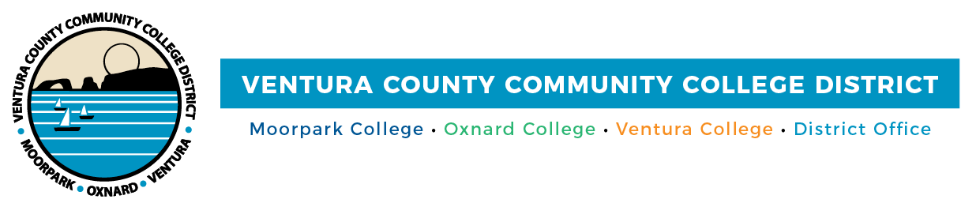

FOR IMMEDIATE RELEASE

Jack Kent Cooke Foundation Awards Gerald Richardson III
Prestigious National Scholarship
Scholarship Provides VCCCD alum with up to $120,000
toward his baccalaureate studies

Camarillo, Calif. (June 8, 2021)—Gerald Richardson III has come a long way from being the “invisible” high school student in a hostile, unwelcoming environment that prevented him access to learning and pushed him into the school-to-prison pipeline. Today, he’s a prominent role model: a 4.0 GPA graduate of Moorpark and Oxnard colleges headed to Stanford University as a 2021 Cooke Foundation Undergraduate Transfer Scholar. The Jack Kent Cooke Foundation scholarship provides up to $40,000 a year for up to three years for Richardson to pursue his bachelor’s degree.

Richardson, who graduated with five associate degrees, was one of over 1,300 students from 370 community colleges nationwide to apply for the scholarship. A total of 72 students were selected based on academic ability and achievement, financial need, persistence and leadership.

As part of the scholarship, Richardson will receive comprehensive educational and career advising, as well as information about opportunities for internships, international study and graduate school funding. This will be important for Richardson, who wants to pursue a doctorate in public policy and a Juris Doctor. Ultimately, he wants to write legislation and work in public service.

“My career goals include living a life of advocacy for human rights. I plan to create a pro-bono law firm for communities made vulnerable by inadequate support and public policy,” explained Richardson.

Mentors at Oxnard and Moorpark colleges empowered him, encouraging him to pursue his “passion for serving others.” Being at the colleges also helped him overcome the experiences of relentless racial bullying and the retaliation he faced in the school-to-prison pipeline. The incidents of being criminalized at school instead of being educated led Richardson to doubt whether higher education was for him, he said.

“Gerald represents what community colleges do best—helping students find their career pathway and inspiring them to spread their wings to take on leadership roles that make a difference in students’ lives,” said Chancellor Greg Gillespie. “Gerald worked hard on causes related to diversity, equity and inclusion within our District, and we valued his insights into the student experience as a student of color.”

Richardson has held several key leadership positions at the local and state level, including legislative affairs director of Region VI for the Student Senate, California Community Colleges (CCC). This spring, the CCC Board of Governors presented him with its inaugural Student Leadership Award. He garnered the award for lobbying California legislators on issues involving equity, basic needs and COVID-19 relief.

“Through his volunteer commitments at the colleges, I’ve seen Gerald grow into a true leader with a strong commitment to social justice causes,” said Board Chair Joshua Chancer. “He worked to broaden the awareness of our students and the community, especially with events such as ‘A Conversation with Dr. Cornel West’ at Moorpark College, which he co-moderated.”

At Moorpark College, he was president of the Black Student Union, public relations officer for the Honors Club and vice president of the African American Male Education Network & Development chapter. At Oxnard College, he served as senate chair for the Associated Student Government. In the community, he served as a director at the Brilliant Minds Youth Foundation and was the founder and president of Youthfully Evolved Society.

About the Jack Kent Cooke Foundation
The Jack Kent Cooke Foundation is dedicated to advancing the education of exceptionally promising students who have financial need. Since 2000, the Foundation has awarded over $222 million in scholarships to over 2,800 students from eighth grade through graduate school, along with comprehensive educational advising and other support services. The Foundation has also provided $115 million in grants to organizations that serve such students. www.jkcf.org

About Ventura County Community College District
The Ventura County Community College District is a member of the 116-campus California Community College system and serves approximately 31,000 students annually. The District’s three colleges--Moorpark, Oxnard and Ventura--offer programs in general education for degrees and certificates, transfer to four-year colleges and universities, career technical education, and provide opportunities to engage in co-curricular campus activities. For more information, please visit vcccd.edu.

Media Contact:
Patti Blair
Director, Public Affairs and Marketing
Ventura County Community College District
communications@vcccd.edu

