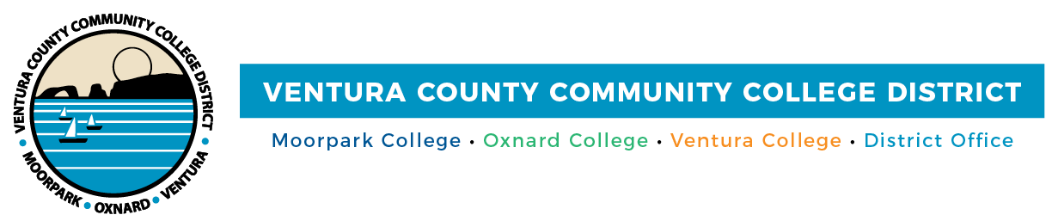
FOR IMMEDIATE RELEASE

VCCCD Celebrates Class of 2021 Graduates
Moorpark, Oxnard and Ventura colleges’ students honored

(CAMARILLO, Calif.) May 21, 2021–Not even a pandemic could stop this year’s graduates of Moorpark, Oxnard and Ventura colleges from pursuing—and achieving—their educational goals. In recognition of what these resilient students have accomplished, the Ventura County Community College District (VCCCD) leadership collaborated with its three colleges to celebrate the 5,370 students in the class of 2021 who have earned their degrees or certificates.

Festive Drive-Thru Graduations were held on May 20 at each college’s campus and Ventura College East Campus in Santa Paula.

“We are always proud of our graduates and all that they accomplish, but this year’s graduates hold a special honor for their persistence in completing their education when most of their classes were remote,” said Chancellor Greg Gillespie. “As these students become VCCCD alumni, they are well-prepared for their next steps of a career or transferring to a four-year college or university.”

“The board of trustees recognizes the successes of the class of 2021 graduates,” said Chair Joshua Chancer. “Despite the pandemic, students worked on their academics and important causes, such as diversity, equity and inclusion for all students and the community.

As part of the celebration activities, graduating students are being highlighted in a virtual yearbook on Moorpark, Oxnard and Ventura colleges’ graduation webpages. Like traditional bound yearbooks, the online version includes photos of participating graduates along with their information and photos of campus life. The 2020 virtual yearbooks took gold in the statewide 2021 Pro Awards by the Community College Public Relations Organization (CCPRO).

The community is invited to visit each college’s webpage to watch graduation speeches by District and college leadership and student leaders. The Ventura College Chorus also performs the Star Spangled Banner via video.

Inspired by the graduates’ achievements, the college presidents offered these heartfelt words:

“Congratulations to Moorpark College graduates who have been resilient in the face of a global pandemic and reckoning with social justice; they have also committed to academic and career success,” said Moorpark College President Julius Sokenu. “We are proud that the class of 2021 has earned 3,209 degrees and 1,535 certificates. They will transfer to top research universities as well as obtain careers in high-demand, high-wage industries. Moorpark College degrees and certificates offer graduates pathways to economic prosperity. Some will earn the promotion that motivated them to return to college. They are the future of our county, region, state and nation.”

“This past year has been devastating for higher education. Yet, in the face of a global pandemic, a concomitant economic abyss that shuttered thousands of businesses, a toxic political environment which spawned an unimaginable insurrection at the nation’s Capitol, and a wave of racist violence that brought our dream of unity and fellowship to its knees, a uniquely resilient cohort of students persisted with their education, most of which was online, and earned the right to graduate this month. These graduates are the very promise of America, and their grit keeps us hopeful that all of the calamities of the past year—and the many other challenges our nation faces—are not insurmountable,” said Oxnard College President Luis Sanchez.

“At Ventura College, our students and their families recognize that graduation is an important milestone in their lives and careers,” said Ventura College President Kim Hoffmans. “Ventura College celebrated its 95th year of providing high-quality, affordable instruction and services to help our students succeed. I personally want to commend and recognize our students for navigating rigorous coursework to accomplish their academic goals. As our graduates chart their future education or career voyages, I hope they apply what they learned at VC to their future endeavors and fondly remember our college.”

About Ventura County Community College District
The Ventura County Community College District is a member of the 116-campus California Community College system and serves approximately 31,000 students annually. The District's three colleges--Moorpark, Oxnard and Ventura--offer programs in general education for degrees and certificates, transfer to four-year colleges and universities, career technical education, and provide opportunities to engage in co-curricular campus activities. For more information, please visit vcccd.edu.

Media Contact:
Patti Blair
Director, Public Affairs and Marketing
Ventura County Community College District
communications@vcccd.edu

