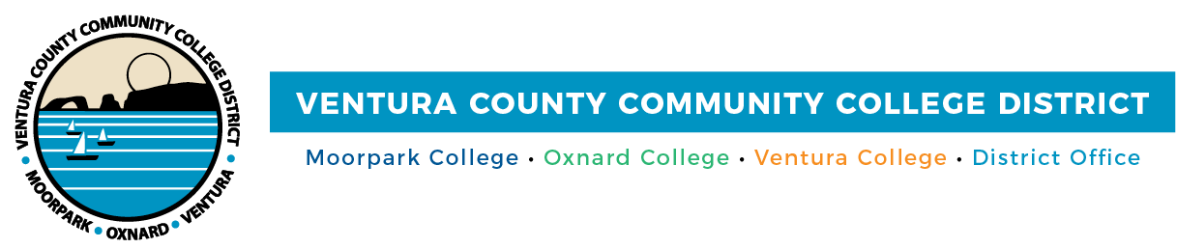

FOR IMMEDIATE RELEASE

VCCCD Names Cynthia Herrera
Vice Chancellor of Institutional Effectiveness
Dr. Herrera brings a wealth of educational and business leadership to the position

(CAMARILLO, Calif.) May 19, 2021—The Ventura Community College District (VCCCD) is pleased to announce that Dr. Cynthia Herrera has been appointed to the position of Vice Chancellor of Institutional Effectiveness. Herrera joined the District in 2009 and most recently served as the Associate Vice Chancellor of Strategic Partnerships, Enrollment and Advancement.

With a strong background in business and educational leadership, Herrera will be responsible for providing Districtwide coordination and leadership to support diversity, equity and inclusion; strategic planning and accreditation preparation; districtwide economic and workforce development; as well as expanding business and industry partnerships and enhancing student success and completion initiatives for VCCCD’s approximately 31,000 students.

“Dr. Herrera couples a deep understanding of the District with visionary thinking, which is a valuable combination for advancing the District’s important initiatives,” said Vice Chair Dianne McKay. “The board looks forward to all that can be accomplished with Dr. Herrera in her new position.”

Herrera’s career with the District began as the Dean of Institutional Effectiveness at Oxnard College. She served as the Accreditation Liaison Officer, using her collaborative, leadership and organizational skills, while building the institutional effectiveness systems to support program review. Herrera worked to build institutional capacity and enhanced student success through continuous substantial improvement.

“I am excited to take on this new challenge with the District,” said Herrera. “My top priorities for this coming year are to partner with Moorpark, Oxnard and Ventura colleges to facilitate a smooth transition for our students from online learning due to the pandemic to in-person, on-campus learning options. I will also facilitate completing a districtwide strategic plan that integrates diversity, equity and inclusivity; prepare for districtwide accreditation; and implement Employment Training Panel funding to minimize the costs to regional businesses for upskilling employees and job-specific training.”

A skilled grant writer, Herrera secured over $35 million in U.S. Department of Education and State of California grants, assisting in the development of Oxnard College’s student support systems, as well as promoting and advancing STEM (science, technology, engineering and math) programs for Hispanic and other under-represented student populations. The grants facilitated first-year experience programs, funded dual enrollment and outreach programs and provided millions of dollars to support the development of STEM curriculum and a STEM Center.

“Throughout her tenure with the District, Dr. Herrera has helped us develop strong partnerships with our K-12 partners, industry leaders, parents, community-based organizations and university partners,” said Chancellor Greg Gillespie. “She has consistently sought increased responsibility and challenges, and has demonstrated exceptional leadership in every position.”

Prior to joining VCCCD, Herrera assisted large organizations for over 20 years in developing resource and business management systems to promote efficiency, success and sustainability.

Herrera earned her bachelor’s and master’s degrees from Western Michigan University and her doctorate from the University of La Verne. A longtime Oxnard resident, she sits on multiple advisory boards and is involved with many community nonprofits and educational committees.

About Ventura County Community College District
The Ventura County Community College District is a member of the 116-campus California Community College system and serves approximately 31,000 students annually. The District's three colleges--Moorpark, Oxnard and Ventura--offer programs in general education for degrees and certificates, transfer to four-year colleges and universities, career technical education, and provide opportunities to engage in co-curricular campus activities. For more information, please visit vcccd.edu.

Media Contact:
Patti Blair
Director, Public Affairs and Marketing
Ventura County Community College District
communications@vcccd.edu

