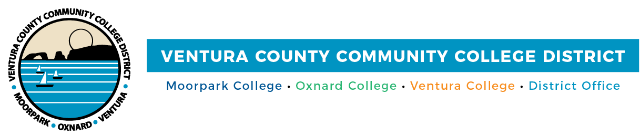

FOR IMMEDIATE RELEASE

VCCCD Board of Trustees Endorses DEI Resolution
District pledges to address the diverse needs of students, faculty
and staff in academia and the workplace

Camarillo, Calif. (April 19, 2021)—Ventura County Community College District board of trustees fully supports and is dedicated to promoting diversity, equity and inclusion (DEI) for its approximately 31,000 students, nearly 1,900 employees and the community. In support of the diverse population of students at Moorpark, Oxnard and Ventura colleges, and the community, the board adopted a resolution Affirming the District’s Commitment to Diversity, Equity and Inclusion at its April meeting.

The resolution is in tandem with the District’s Diversity, Equity and Inclusion Week and the California Community Colleges’ Diversity, Equity and Inclusion (DEI) Awareness Month.

“VCCCD is a welcoming and inclusive equity-minded, anti-racist learning environment where diverse students are supported to pursue and attain student success,” said Trustee Gabriela Torres. “Our mission is to foster social justice and an inclusive, equity-minded learning environment where all students receive support to achieve academic success and attain the necessary skills to find meaningful work that offers them a living wage.”

The District has a diverse student population that mirrors California’s residents. It counts nearly 54% as Latinx, 30.23% as White, 6.5% as Asian, 1.63% as Black, 0.23% as Pacific Islander, 0.21% as Native American, 4.20% as two or more Races and 3.46% as Unreported. In the state, the community college system provides many students a means for upward mobility and a better life, particularly those who are the first in their families to pursue higher education.

“The board takes pride in approving this resolution, which meets the myriad needs of our diverse faculty, staff and student body,” said Chancellor Greg Gillespie. “We believe the concepts of diversity, equity and inclusion provide a blueprint for respect, understanding and fairness in the classroom, the District and beyond. Every person deserves opportunities to contribute to their community and to flourish both personally and professionally.”

The resolution covers various forms of diversity, including race, ethnicity, language, culture, nationality, social-economic class, age, physical ability, religious beliefs, gender and sexual orientation.

The District will take numerous steps to advance diversity, equity and inclusion at its colleges related to board policies, employment, professional development, campus culture and curriculum. These actions include:

- Students: Prioritize efforts to include the student voice to inform board policies and actions related to faculty and staff diversity.
- Board Policies: Develop statements by the board in support of diversity, equity and inclusion.
- Human Resources: Identify actions to address underrepresentation in current staffing.
- Equal Employment Opportunity Plan: Develop actions related to faculty and staff diversity supported by national, state and local data.
- Equity Plans: Review and update the Equity Plans with the goal of infusing actions to uplift the most vulnerable and socially disadvantaged students in the VCCCD system.
- Professional Development: Develop efforts to support increased cultural competencies among staff and faculty, and understand implicit bias.
- Campus Climate and Curriculum: Encourage campus dialogue, and develop an audit of classroom climate and action plans to create inclusive classrooms and anti-racist curriculum.

About Ventura County Community College District
The Ventura County Community College District is a member of the 116-campus California Community College system and serves approximately 31,000 students annually. The District's three colleges--Moorpark, Oxnard and Ventura--offer programs in general education for degrees and certificates, transfer to four-year colleges and universities, career technical education, and provide opportunities to engage in co-curricular campus activities. For more information, please visit vcccd.edu.

Media Contact:
Patti Blair
Director, Public Affairs and Marketing
Ventura County Community College District
communications@vcccd.edu

