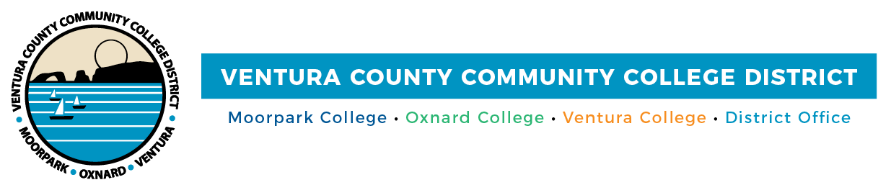
FOR IMMEDIATE RELEASE

VCCCD Issues Statement Regarding Video of Faculty Member

Camarillo, Calif. (February 19, 2021)—The Ventura County Community College District is deeply troubled by the behavior seen in a video posted on social media by students on Feb. 18, showing an interaction between a student who is hard-of-hearing and an Oxnard College faculty member.

“The Ventura County Community College District is opposed to any language or behavior which is offensive or harmful to anyone based on gender, ethnicity, religion, sex orientation, age or disability,” stated Board Chair Joshua Chancer. “Comments in the video do not reflect the District’s values of integrity and honesty in action and word, respect and the constant pursuit of excellence.”

“Oxnard College is wholeheartedly committed to treating all of our students with the utmost respect. We denounce discriminatory behavior or harassment of any kind and we remain deeply resolved to providing a safe and welcoming learning environment for students of all backgrounds,” commented Oxnard College President Luis Sanchez.

“We are all concerned regarding the student and faculty member interactions and will take appropriate actions at the conclusion of the investigation. We are committed to supporting the success of our students and will be reaching out to all students in the class to support them in their continued success,” commented Chancellor Greg Gillespie.

District leadership has initiated an investigation and placed the faculty member on an immediate administrative leave. This investigative process could take approximately three months, and the District is committed to being thorough and fair.

About Ventura County Community College District

The Ventura County Community College District is a member of the 116-campus California Community College system and serves approximately 31,000 students annually. The District's three colleges--Moorpark, Oxnard and Ventura--offer programs in general education for degrees and certificates, transfer to four-year colleges and universities, career technical education, and provide opportunities to engage in co-curricular campus activities. For more information, please visit vcccd.edu.

Media Contact:
Patti Blair
Director, Public Affairs and Marketing
Ventura County Community College District
communications@vcccd.edu

