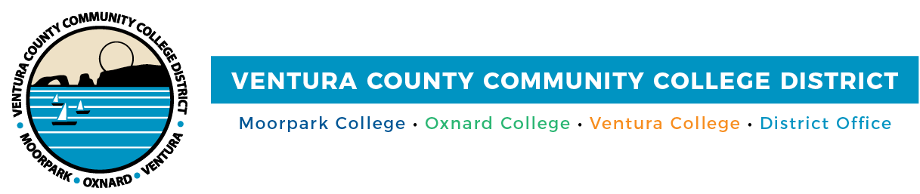

Cash 4 College
Workshops Help Students Access Funds for College

(CAMARILLO, Calif.) January 22, 2021 – To help students overcome the challenge of paying for college, Moorpark College, Oxnard College, Ventura College and Ventura College East Campus are holding free Cash 4 College workshops via Zoom. A workshop will be held on Feb. 6 and Feb. 20 and students can drop in anytime during the session (details below). Bilingual financial aid staff will assist students in completing applications for the 2021-2022 school-year FAFSA (Free Application for Federal Student Aid) or the California Dream Act Application (CADAA). The workshops are free and open to the community; people may attend a workshop on either date.

Advanced registration is preferred. For more information, visit vcccd.edu/cash4college

Moorpark College, Oxnard College, Ventura College and Ventura College East Campus
Saturday, February 6
Saturday, February 20

9 a.m. to noon
Zoom link: http://bit.ly/C4Cspring21
Join from PC, Mac, Linux, iOS or Android

Please contact your college’s financial aid office with any questions:

Moorpark College Financial Aid Office Phone: (805) 378-1462
Email: mcfa@vcccd.edu

Oxnard College Financial Aid Office Phone: (805) 678-5828
Email: oocfinaid@vcccd.edu

Ventura College Financial Aid Office Phone: (805) 289-6369
Email: vvcfinancialaid@vcccd.edu

Ventura College East Campus Financial Aid Office Phone: (805) 289-6574
Email: wwendolyne_lopez1@vcccd.edu

About Ventura County Community College District
The Ventura County Community College District is a member of the 116-campus California Community College system and serves approximately 31,000 students annually. The District's three colleges--Moorpark, Oxnard and Ventura--offer programs in general education for degrees and certificates, transfer to four-year colleges and universities, career technical education and provide opportunities to engage in co-curricular campus activities. For more information, visit
www.vcccd.edu.
###

Media Contact:
Patti Blair
Director, Public Affairs and Marketing Ventura County Community College District
communications@vcccd.edu

