Ventura College Sabbatical Leave Final Report
Resources for New Faculty Needed to Combat the “Sage on the Stage” Vision of College-level Teaching
Submitted by Sharon Beynon
English Department
For Sabbatical during Fall 2016/ Spring 2017

This report summarizes the sabbatical project I completed during fall semester 2016 and spring semester 2017. I am sincerely grateful to the Board of Trustees for approving my sabbatical. With the help of Ventura College’s distance education professionals, professional development committee and colleagues in various departments, I was able to put together resources that were used by new full and part-time faculty to improve their teaching practices and their integration into the campus community.
Background of Sabbatical Project
In 2015, Ventura hired over 20 new part-time faculty members, many with limited or no pedagogical training. Similarly, we hired almost 20 new full-time faculty members, many of whom subscribe to lecture methods primarily and know little about the college’s student services or cultural offerings. So, although all new instructors have advanced degrees and convinced hiring committees of their commitment to students, many walk into the first day of class relying on their own educational experiences to guide their pedagogy. Often, college professors lectured them, so they lecture as college professors. Ironically, teachers are often highly successful students who learned well in lecture-based classes. Often attending elite institutions, they understood how to navigate the complex social world of academia. A Hispanic Serving Institution, Ventura College places over 70 percent of students into at least one remedial class. Often, our students have not been fortunate enough to receive the kind of high school education that prepares them for college-level work. Further, as an open-access, 21st Century Institution, students need instructional methods that help them engage with difficult material. With this in mind, mentoring new faculty is important for the following reasons: - Knowing about well-researched high impact practices legitimizes non-lecture forms of teaching (The RP group and the CCCSE reports offer practical suggestions in this area) - Knowing campus resources allows instructors to direct high achieving and struggling students to the resources they need - Knowing other faculty to increases new faculty access to institutional knowledge - Currently, I have worked with other members of the Professional Development Committee to pilot a mentoring system for new part-time faculty. We developed a D2L page for Mentors and Mentees and assigned a mentor to each new faculty member. The Professional Development Committee has offered FLEX-week orientations for new full-time faculty and new part-time faculty. We are following up with a mid-semester session to help guide new faculty through finals and grade submission. The pilot has been enthusiastically greeted both by current instructors and new faculty. There is not the time nor energy on the part of the current group to refine this and hone it into a meaningful Mentor Program. 
Results of Sabbatical Project
Much of the work done during my sabbatical funneled into the roles I played on campus. So, to illustrate the work done, I will pull a few sample documents (the Canvas Shell created can be accessed via Canvas Courses.)
As a Professional Development Committee member and chair, I had worked to develop flex sessions relevant to good pedagogy. As a co-lead on the New Faculty Experience in academic years 2017 and 2018, resources gathered during my sabbatical were put into the New Faculty Experience Canvas Shell. Working with Nathan Cole and later with Tania DeClerck, we met with new faculty in an effort to mentor them on campus.
The research I did showed that creating trust and community are key to helping faculty experiment with non-traditional teaching methods. The tone of meetings and gatherings matter a great deal. Here is a sample of our method and tone:
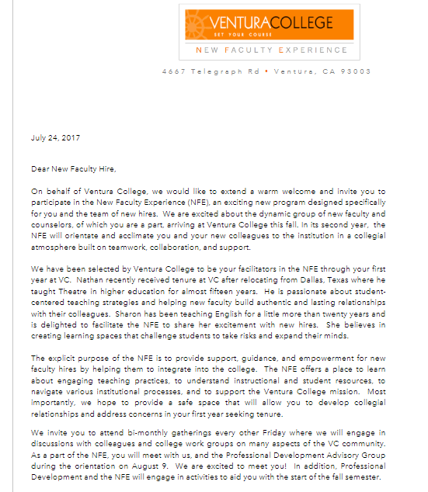

Here is a page from the Canvas Shell we created showing the sections for the practical needs of new faculty. Each of these tabs opens into detailed help for faculty. This was useful as this created one place for new faculty to go for help. More than the online help, however, was the face to face, person to person, help we focused on.
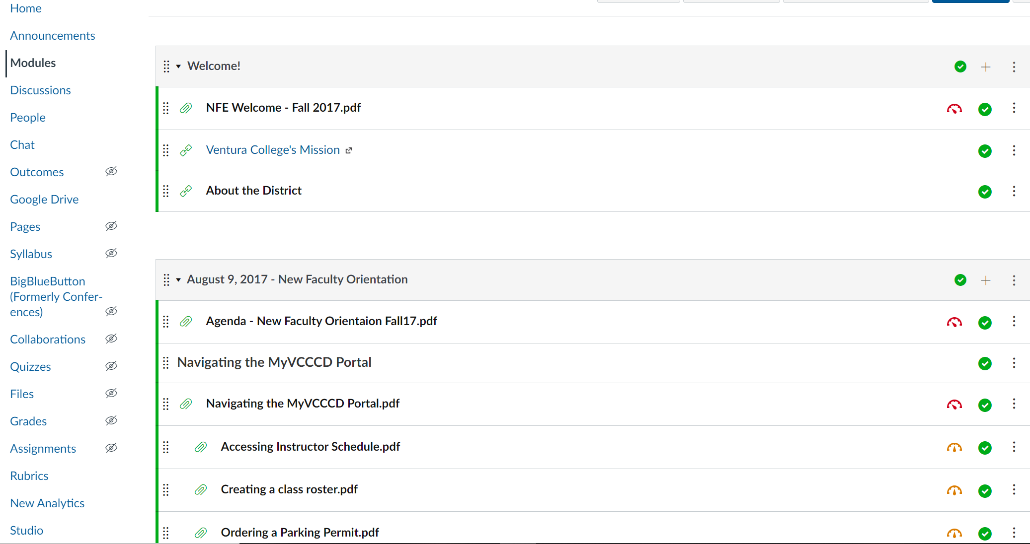

Another sample of work done during my sabbatical focuses on the building of meaningful communities and the connections those communities create. Re-reading Courage to Teach during my sabbatical, I was reminded of the work Parker Palmer encourages teachers to engage in as they reflect on how they “teach who they are.” The flyer below was for a talk related to this text, co-hosted with Henny Kim, who is certified by UCLA in mindfulness instruction.
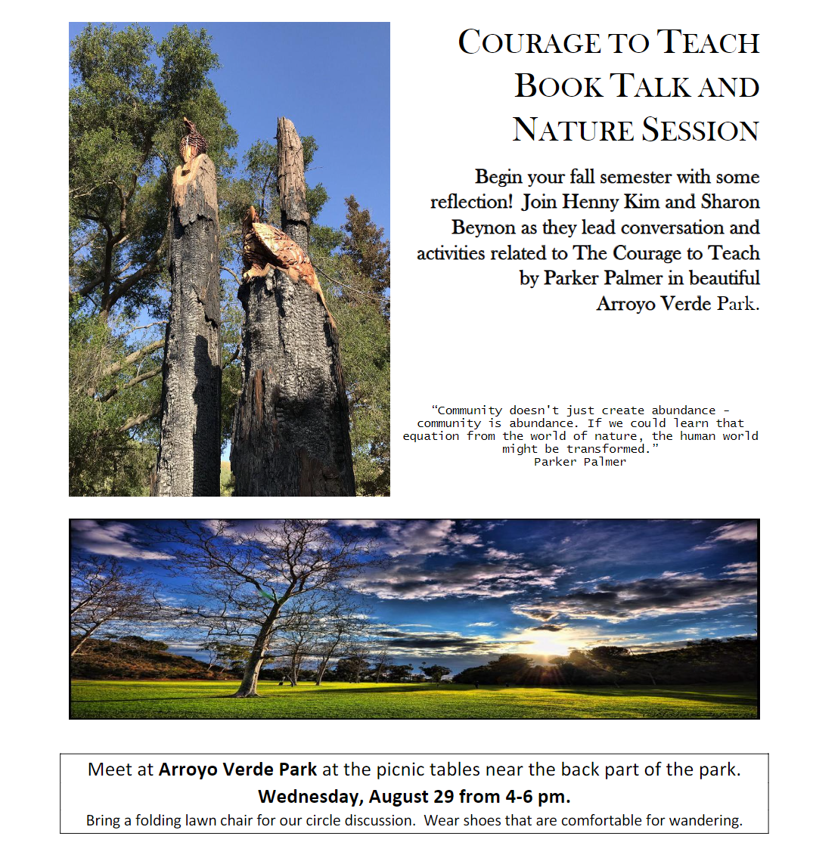

Value of Sabbatical Project
The disparate projects that grew from my sabbatical work gave me great joy. My passion for experiential, meaningful teaching and for collegial community at Ventura College intertwined. I look at this work as part of the beginnings of the Canvas shell evolution. These kinds of resources and compilations will only become better and better. As with anything relating to teaching and students and the messy reality of learning, I strongly feel that we must continue to re-invent ways to connect our faculty with each other and with important conversations about our vision for our students. This work, hopefully, contributed to that.
Most respectfully,
Dr. Sharon Beynon
Professor of English
Ventura College

